|  |
| --- |
| Arctic Math |
|  |

|  |  |
| --- | --- |
| Mark Raguraam Sounthararajah  Candidate Number : 4130 | Westcliff High School for Boys  Centre Number : 16635 |

Contents

* Definition
  + Identification and Background
  + Current methods used
  + THE PROJECT
  + THE USER
  + KEY POINTS
* Investigation and Analysis
  + SURVEY
    - Participants
    - Resources
    - Operating System and Access
    - Feasibility and Application Features
    - Competition
    - Purpose and Education
  + Review of curent syStems
    - MyMaths
      * Introduction
      * review
      * Conclusion
    - Isaac Physics
      * Introduction
      * review
      * Conclusion
  + Areas for development
    - MYMATHS
    - ISAACPHYSICS
    - Conclusion
  + Requirements
    - Hardware and software Requirements
    - User Requirements
* design
  + PROJECT - PROBLEM DEFINITION
    - Purpose
    - Colour scheme
    - Information
    - Font
    - Logo
      * Design 1
      * Design 2
      * conclusion
    - Mathematical Notation
    - Abstraction - Pseudocode
* Development
  + user Interface
  + Questions Algorithms
    - Quadratic Equation Genreator
  + Problems encountered During development
* testing
  + White box Testing
  + Black Box Testing
  + Alpha Testing
  + Beta tESTING
* Evaluation
  + Evaluation of Requirement Specification
  + User Requirements
  + Limitations
  + fINAL Evaluation

DEFINITION

# Identification and Background

I am currently an A Level student studying Mathematics, Computer Science and Economics. As an A Level Mathematician with a brand-new specification, I find the sheer lack of updated resources to aid my revision and that of my peers utterly disappointing. In the market, all the free and freemium or paid alternatives either have various levels of advertisements, which can disrupt the flow of focused "in the zone" revision or are slightly to entirely irrelevant to the current standard of exam boards e.g. Non-Calculator Work when all papers pertaining to the new A-Level specification require a calculator.

Moreover, without a Textbook or a Workbook from which to answer questions, revision for mathematics may seem challenging outside of any apt revision environment; These questions may only show the result and not the methods used to achieve the answer. This is true especially in the Applied Mathematics Section (Statistics and Mechanics) as approaches to questions can become more varied and any small numerical errors can cause a chain effect creating a series of mistakes. This is much unlike the humanities and other physical sciences where notes can be learned relatively easily, using revision aids such as cue cards, without that much need to apply techniques to remember how to apply them in varying scenarios.

In Addition, most alternatives are for international students following schemes such as the Advanced Placements from the US and the International Baccalaureate. This means that they do not have all the appropriate content due to them not being focused on the new A Level Specification.

# Current methods used

Textbooks with exercise questions, for the moment, seem to be a preferred method by mathematics teachers used for learning and assessment but they can be very expensive even with school bulk discounts which happened in our very school at the start of the year despite the government “math premium” of £600/additional A Level Mathematician in the 2017 Autumn Budget by Philip Hammond, the Chancellor of the Exchequer. Also, for example in my state school, printing 115 copies of past papers for each mathematics student is very costly and these handouts can easily be damaged, lost or just forgotten about before the next lesson wasting the investment into that students’ education. The use of hard copies to answer questions also requires other resources such as paper, pens and their ink, pencils, rulers, calculators, protractors and various other mathematical instruments which are not in the slightest bit portable or easily transferable to an apt revision environment.

Moreover, currently the main online challengers to Arctic Math are MyMaths and Khan Academy which are used by students to learn and build upon their knowledge whilst going through continuous assessment whilst teachers can measure progress on individual levels. These websites however have a litany of complaints as for example “if you get just one part of a question wrong, you have to do an entire section again with different questions, not just the type of question you got wrong” And “One question, it asked for the answer to 1 [d.p.] – [the student] came up with 7.543 so [the student] put down 7.5 … the system marked it wrong and gave 7.6 as the "right" answer. Result is that [the student] now has to do the whole section again through no fault of his own.” - (Source: [Mumsnet - Why do teachers use [MyMaths]](https://www.mumsnet.com/Talk/secondary/2875490-My-Maths-why-do-teachers-use-a-program-thats-so-often-wrong)). These complaints were just a few of many found on Mumsnet which is a website for parents in the UK that hosts discussion forums where users share advice and information on parenting and many other topics.

A dynamic website could negate many of these issues as it would portable, cheap, easily accessible and therefore the most practical and effective revision method for the bulk of A Level students. It would also be trained to prevent issues like the one complained about above on Mumsnet. In addition, it is highly unlikely students will damage expensive personal electronics due to their value to them unlike a, free at the point of use, school textbook. Due to this, it is reasonable to believe that students will take care of these more than they would of past paper handouts or textbooks. This increased care may also lead to a reduction in the number of students dismissing revision due to its easy accessibility which in the long run would help to boost aggregate revision of the cohort hence theoretically boosting results.

# The project

My Project is going to be an A Level Mathematics Revision Website with Topic Based Automatically Generated Questions as well as Past Paper Questions for the new Edexcel 8MA0 and 9MA0 A Level Mathematics Specifications. This shall be primarily built up in PHP, which is a server-side scripting language designed for Web development, as well as any other additional languages as required; These additions will most likely be used when libraries are not compatible across languages and so connections to other languages will have to be made.

This project lends itself to be solved using Computational Methods due to its Inherent Mathematical Nature. The generation of random questions would take much more time to find from textbooks or created manually compared to auto generation. This will also be cheaper and more convenient.

# The user

The primary users of this website will be A Level Mathematicians with their examinations in Summer 2019 and later but there are other possible end users; GCSE students may choose to use this website as a form of extension work, especially those top students who achieve Grade 8’s and 9’s and/or taking any variant of an extra mathematics qualification at GCSE such as Further Mathematics, Additional Mathematics or Statistics. Also, Undergraduates of Science, Technology, Engineering, Mathematics (STEM) and quantitative social sciences may use this to help them consolidate their understanding of key topics in order for them to learn Quantitative Modules at University which may require them to apply the A Level Mathematics Content. Due to these various potential audiences there is a very big number of prospective clients as numeracy is very important in almost all quantitative academic fields from Computer Science and Economics to Geography and Psychology.

# Key points

The most important features of my A-Level Mathematics Revision website:

1. A straightforward Graphical User Interface
2. The ability to select questions from specific topics
3. Links to resources are working optimally
4. Consistent Number of Decimal Places or Significant Figures
5. Easily Accessible Revision Notes
6. Real Past Paper Questions from the 8MA0 and 9MA0 Specification
7. The ability to select random questions from the specification
8. Questions having a quick marking turnaround time

Extensions

1. The ability for teachers to monitor the progress of students
2. A Leader board
3. Progress Reporter
4. Reminders to do Work
5. Question Submittal for Working and Answers from Peers

Investigation AND Analysis

# Survey

This will be my primary technique to collect information about the probable users.

I emailed out my survey to my Mathematics mentees in Year 10,11, my peers in Year 12,13 and my Older Friends at University. I received 15 responses out of 21 emails. Due to the small sample size, the findings may not necessarily represent the views of the intended audience.

In addition, the sample may not be large enough to give accurate information about different types of A-Level Mathematics students. There may be a bias in the answers to the questions due to the majority of candidates sharing the same educational history for at least 5 Years. Due to this , the perceived requirements suggested by the findings of the survey may not actually be appropriate for the general cohort of A-Level Mathematicians nationwide on average.

My Survey was comprised of 23 Questions which varied from Binary Yes or No Questions to Questions needing a 1 to 5 Rating as well as User written comments, a ranking question and selection of applicable categories.

**Participants**

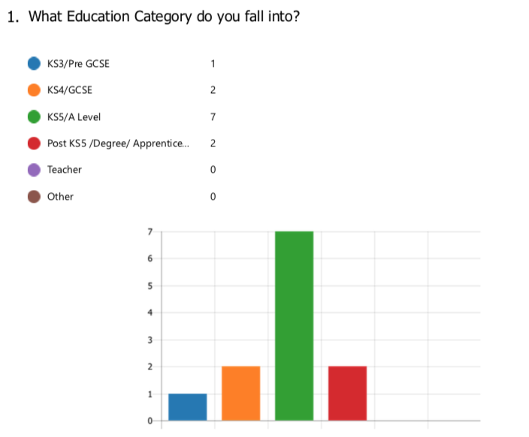My 1st Survey question asked what Education Category the respondent was in. This can help me to see how old potential users could be ;This would aid in planning for future development i.e. Prioritise KS4 and University Students over those in KS3.

The results of this survey tell me that the majority of those who responded to the survey were in the main target audience and so the sample should be accurate enough to represent the requirements from that group of students.

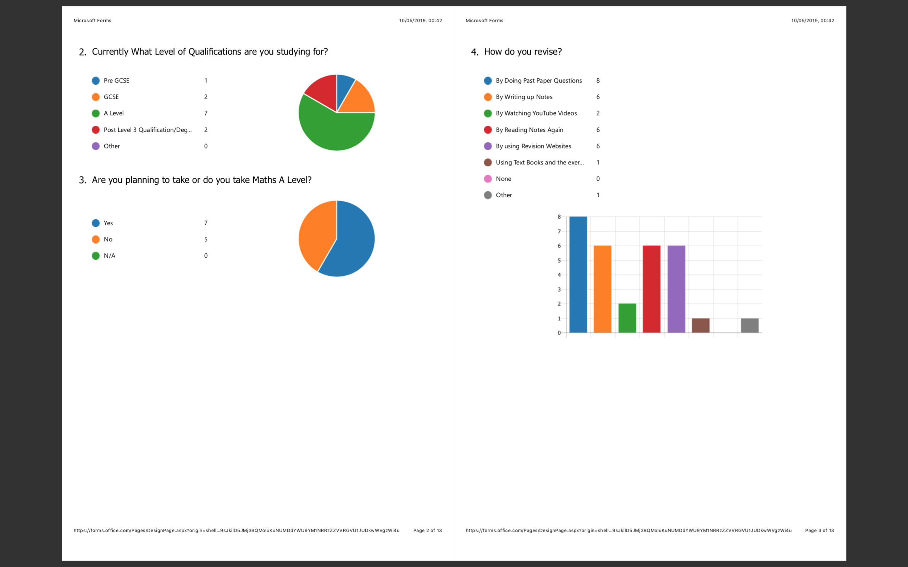

My 2nd Survey Question asked what Level of Qualification that the respondent was studying towards. This is to make sure that the needs of the target audience are reflected accurately as even though most of the respondents were at KS4 level in terms of their academic ability, there were a few who were just not at the same level as their peers.

The results of this survey tell me again that the majority of those who responded to the survey were in the main target audience and so the sample should be accurate enough to represent the requirements from that group of students.

My 3rd Survey Question simply asked whether or not the respondent plans to take or is taking Mathematics at A-Level. This is to see exactly how many potential users which is just under 60% of the respondents.

The results of this survey tell me again that the majority of those who responded to the survey were in the main target audience and so the sample should be accurate enough to represent the requirements from that group of students.

Resources

My 4th Survey Question asked what the respondents’ revision methods were. The majority of students selected Past Paper Questions as an option and Revision Websites came tied 2nd cumulatively with Note Making and Reviewing . The worst response arguably was from a teachers’ favourite of using the Textbooks and the Questions within.

From this data, I understand I should not have my website be like a Textbook with irrelevant information and no clue on how to solve Questions. My website may include links to helpful documents on how to attempt to solve questions.

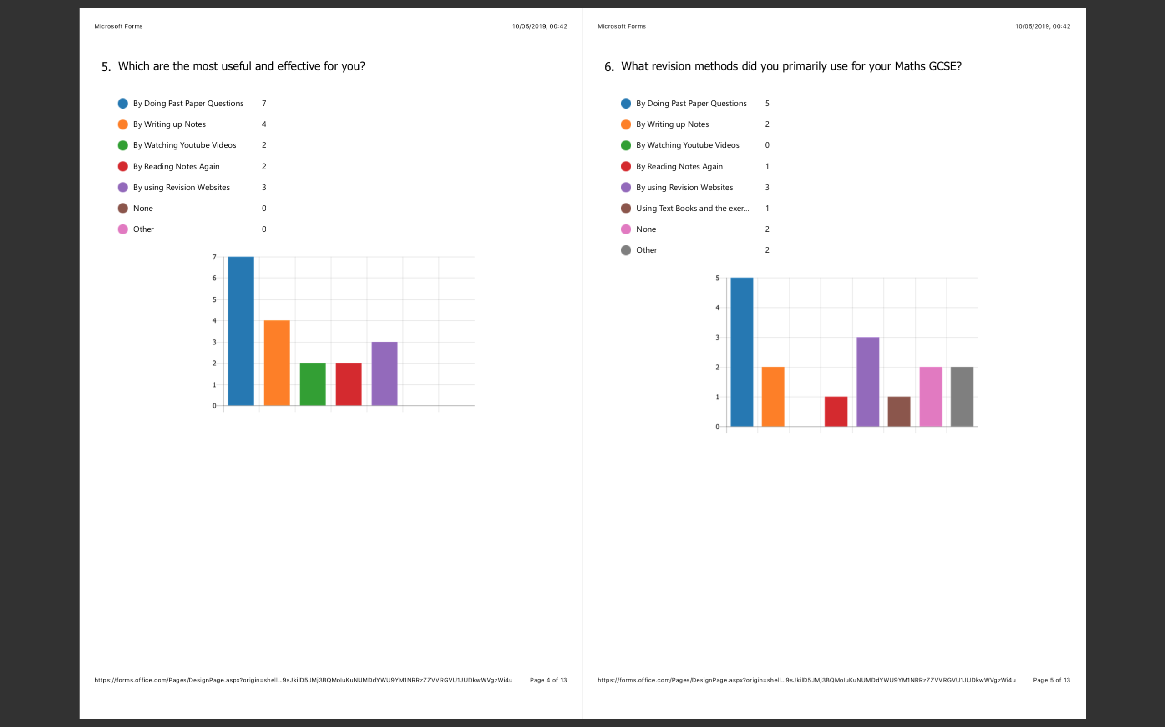

My 5th Survey Question followed on from the prior question . The 5th question asked what the respondents’ most useful and effective revision methods were. Rewriting Notes came 2nd whilst Revision Websites followed at 3rd .

This would aid in planning for future development; For example, I could Have an accompanying set of notes to each topic If I had enough personal time as 9MA0 Mathematics Notes do not come under the scope of H446 Computing.

****My 6th Survey Question was similar to the prior question but The 6th question asked what the respondents’ most used revision methods were during their Mathematics GCSE . Rewriting Notes came 2nd whilst Revision Websites followed at 3rd .

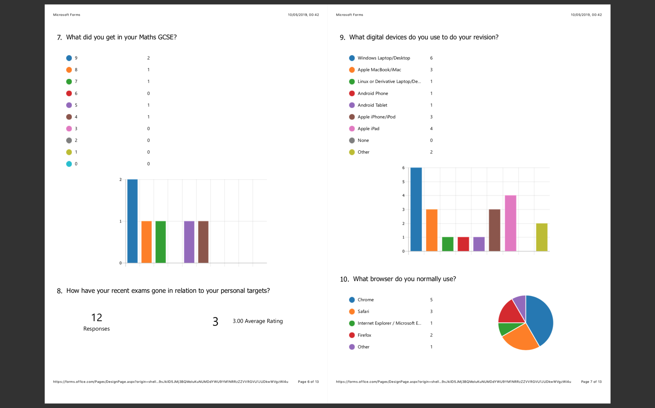

My 7th Survey Question asked what the respondent got for GCSE Mathematics. This was so I could see pre-existing levels of knowledge of Mathematics. Due to the personal nature of the Data, the Survey was anonymized.

From this data, I understand I should have my website be accessible/interpretable to students following alternative paths to post 16 Mathematics Education such as Core Mathematics.



My 8h Survey Question asked what the respondent felt about their last examination cycle in comparison to their own goals. This question has been asked so that later down the line It can be asked again to the original respondents to see if Arctic Math has had a noticeable effect.

**Operating System and Access**

My 9th Survey Question asked what devices the Respondents use to do their revision. This was in order for me to identify the major operating systems in the case of an additional physical application. The Blue Bar on the adjacent chart would suggest that Windows Computers reigned but the Apple Eco System linking iPhone/iPod to iPad means that cumulatively Apple has the lead. There are few Android Devices and even less Linux distros.

However , due to the wide Variety of Platforms a Cross-Platform Solution may be ideal to implement. As this doesn’t inherently discriminate against any one group. This will also help to ensure the highest levels of distribution of Arctic Math.

****My 10th Survey Question asked what their main Browser. This was in order for me to identify the major Browser in the case of implementing extensions or pop-out notifications. Winner by relatively far is Chrome followed by Safari and Other browsers with 1 or less votes.

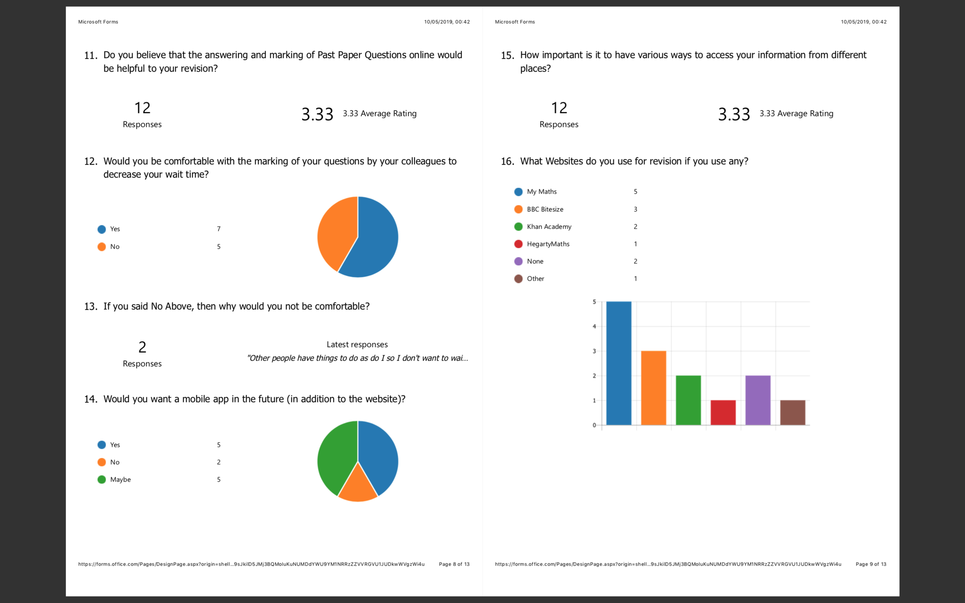**Feasibility and Application Features**

My 11th Survey Question asked what the respondent felt about answering and marking Past Paper Questions online This question has been asked so that later down the line It can be asked again to the original respondents to see if Arctic Math has had a noticeable effect.



My 12th Survey Question simply asked whether or not the respondent would be comfortable with someone else marking your answers. This is to see exactly how many potential users want peer marking which is just under 60% of the respondents.

The results of this survey tell me again that the majority of those who responded to the survey were in the main target audience.

My 13th Survey Question was only visible to those to who selected No for My 12th Survey Question thanks to the ability to branch to different questions dependant on responses. Major concerns here were Privacy and Time Lag which are very legitimate concerns.

**Extensions**

My 14th Survey question asked whether an app would be wanted. This can help me to see how old potential users could be ;This would aid in planning for future development i.e. Make an iOS App in XCode as that has the largest portion of the target audience market.

My 15th Survey Question was similar to the prior question but The 15th question asked about the general portability of information. The average score of 3.33 is above the midpoint of 2.5 but not enough to warrant wide scale information portability.

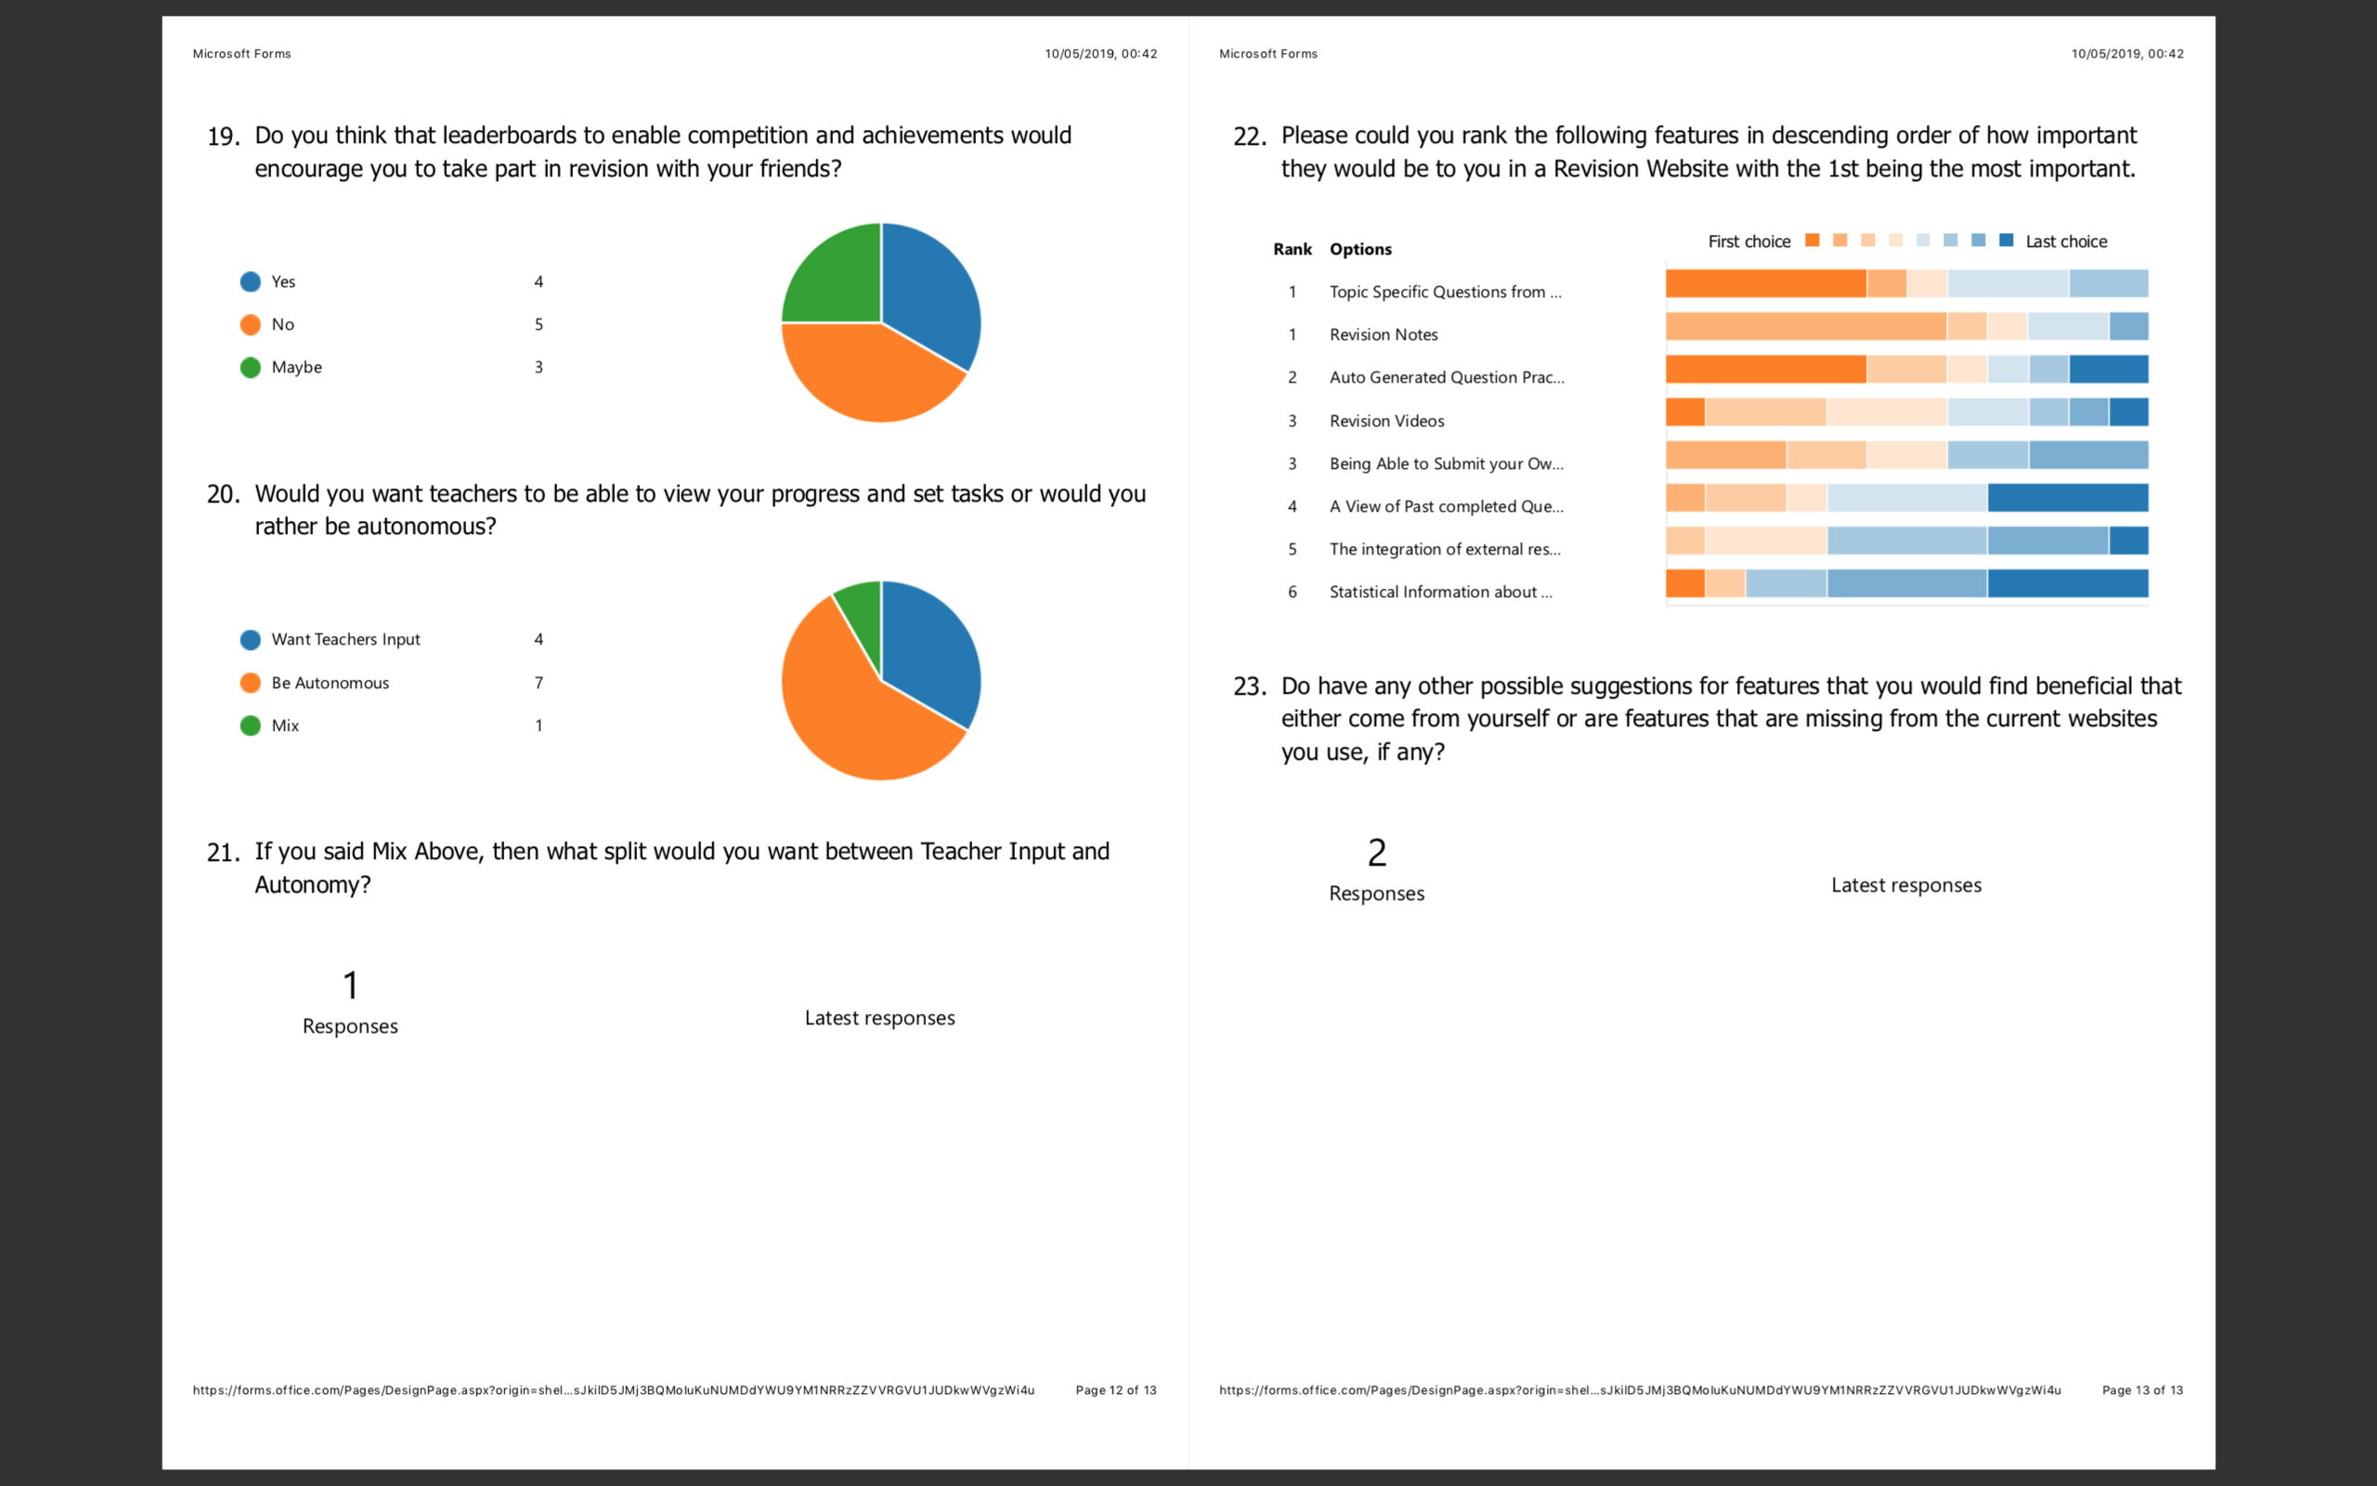

My 19th Survey question asked whether an leader board would be conducive to study. This informed that the audience don’t want a leader board which is perfectly understandable as you may feel insignificant if you have a low to middling score whilst people at the top of the leader board have more points than you in magnitudes of 1000s.

**Competition**

My 16th Survey Question asked what websites the Respondents use to do their revision. This was in order for me to identify the competitors in the market. The Blue Bar on the adjacent chart shows MyMaths large proportion of students compared to the much smaller competitors.

My 17th Survey Question asked how often the Respondents use the websites to do their revision. This was in order for me to identify requirements for running a live server. 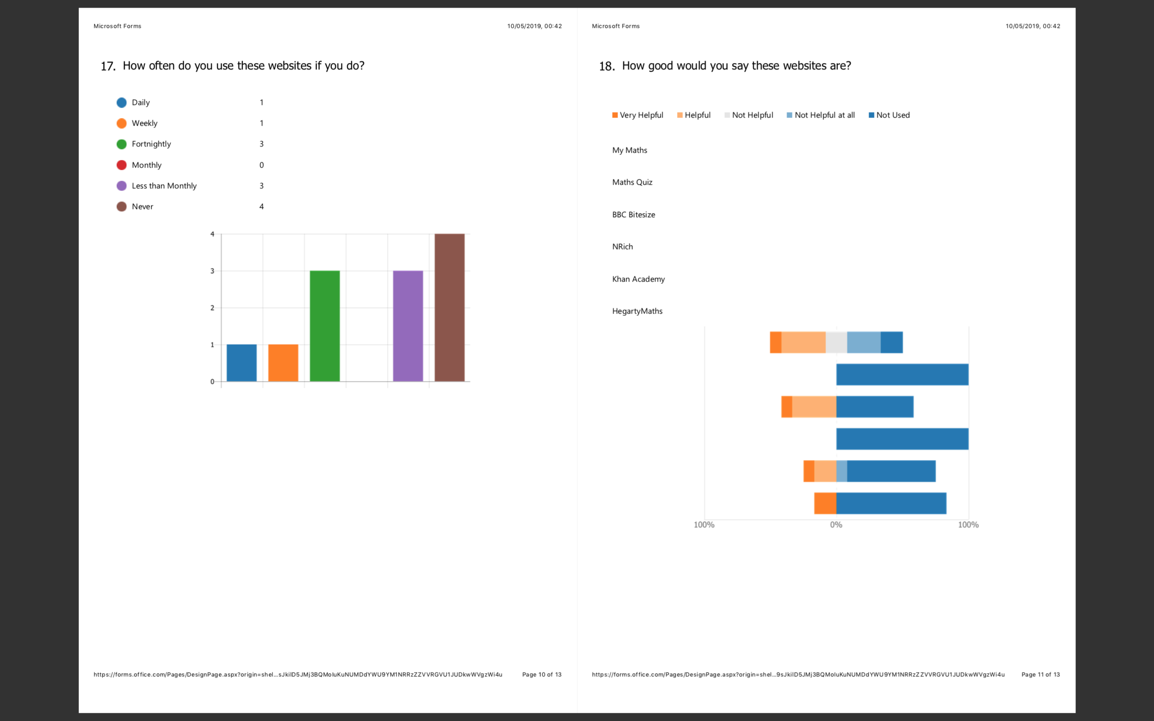 However, this data clearly shows that the biggest category is Never using the website which can seem very confusing and surprising on 1st view but on a 2nd glance students may not find the website easily accessible or irritating so they won’t do work.



My 18th Survey Question asked the Respondents to rank the websites in order of their preference. This would let me able to scour these websites for why people want to use them. However, this data clearly shows that the biggest category is MyMaths which is slightly odd as “for example “if you get just one part of a question wrong, you have to do an entire section again with different questions, not just the type of question you got wrong” And “One question, it asked for the answer to 1 [d.p.] – [the student] came up with 7.543 so [the student] put down 7.5 … the system marked it wrong and gave 7.6 as the "right" answer. Result is that [the student] now has to do the whole section again through no fault of his own.” - (Source: [Mumsnet - Why do teachers use [MyMaths]](https://www.mumsnet.com/Talk/secondary/2875490-My-Maths-why-do-teachers-use-a-program-thats-so-often-wrong)).”

Purpose and Education

My 20th Survey Question asked the Respondents to pick if they should be autonomous or have teacher input . Unsurprisingly in my opinion , The votes for Autonomy almost doubled those for the Teacher Input. This strongly shows that students do not want teachers to interfere which could be biased due to the past experiences of Maths Revision websites such as MyMaths which can be very limited without a teacher.

My 21st Survey Question was only visible to those to who selected No for My 20h Survey Question thanks to the ability to branch to different questions dependant on responses. The only Mix Response I was given was “50:50” by one of my peers in Year 13 . However, this may not be as feasible as teachers may demand more control of a learning resource that students do not want to give up.

My 22nd Survey Question asked the Respondents to rank some potential features in order of their preference. This would let me able to see if these features were worth implementing before considering requirements. A joined 1st place is Topic Specific Questions which can be linked to due to the many online collations of Questions based on Topic .Also joint 1st is Revision Notes which I have said could be an accompanying set of notes to each topic If I had enough personal time as 9MA0 Mathematics Notes do not come under the scope of H446 Computing.

My 23rd Survey Question was a final request for comments , improvements and critiques. Half of the 2 responses were useful. A peer suggested Personalised Feedback rather than a standard boilerplate. The comment “no” was also quite intriguing.

REVIEW OF CURRENT SYSTEMS

MYMATHS

# Introduction

MyMaths is a mathematics revision website, based on the deprecating Adobe Flash, currently used by 4 million students in 70 countries with over 80% of UK Secondary Schools using it. It requires a subscription which schools can obtain depending on the size of the school’s mathematics cohort. It includes KS3, GCSE and quite a lot of the A Level in Mathematics and it does cover the new specification which Is where I will be focusing upon. My School has been using MyMaths from Y7 which I know from personal experience as well as conversing with the current Head of Mathematics and it has proven its’ worth arguably despite its annual fee of £625 excluding VAT. I shall be exploring some of the features that I believe are key to the status of MyMaths as one of the most widely used online mathematics resource online due to its’ utility for students despite some its less helpful features which I will be scrutinizing to create a better summative revision resource.

# Review

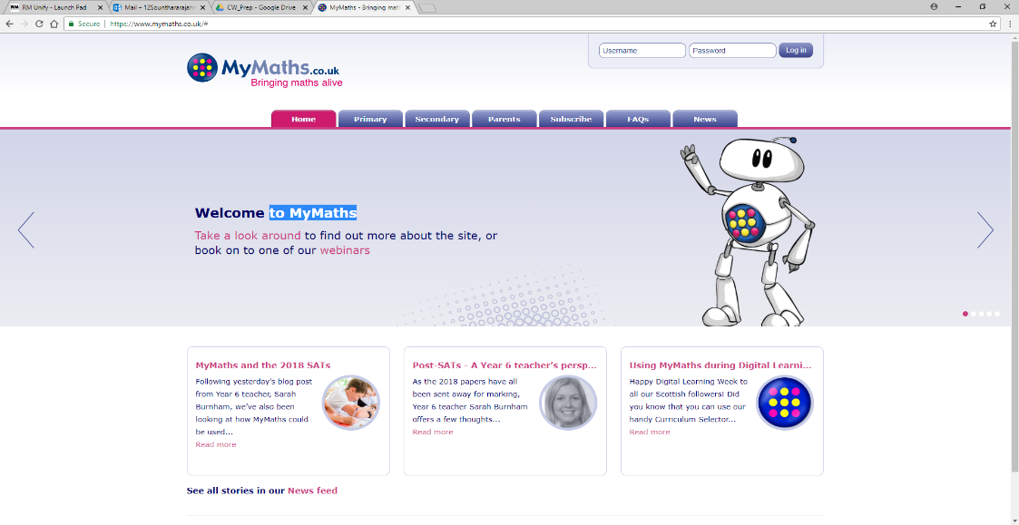Upon loading mymaths.co.uk you are greeted with a welcome screen. It has tabs indicating whatever information is required. In the top right corner, a username and password are requested which schools can obtain through a subscription service.



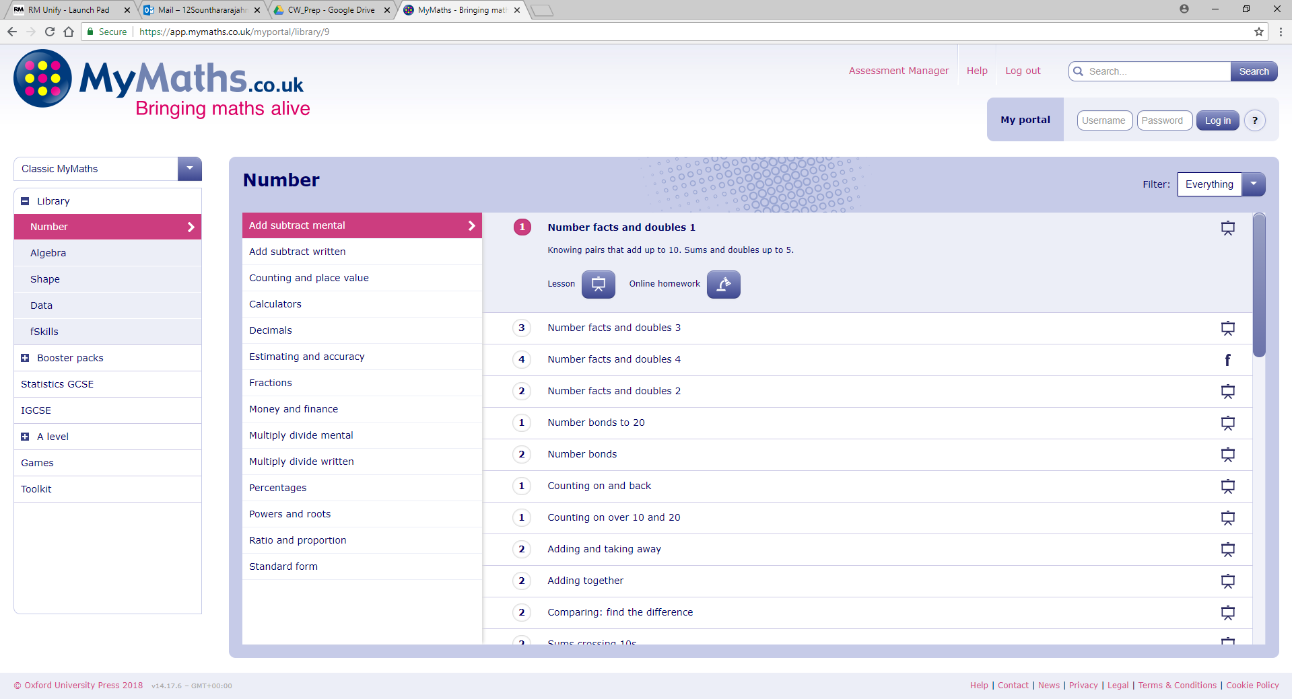

After logging in with the school username and password, you are ushered to the main portal; This is where all the revision aids and questions are stored. Underneath *the search bar in the top right corner, there is a unique portal traveler which with personal login details can takes users to their individual areas so that teachers can monitor the progress of students.



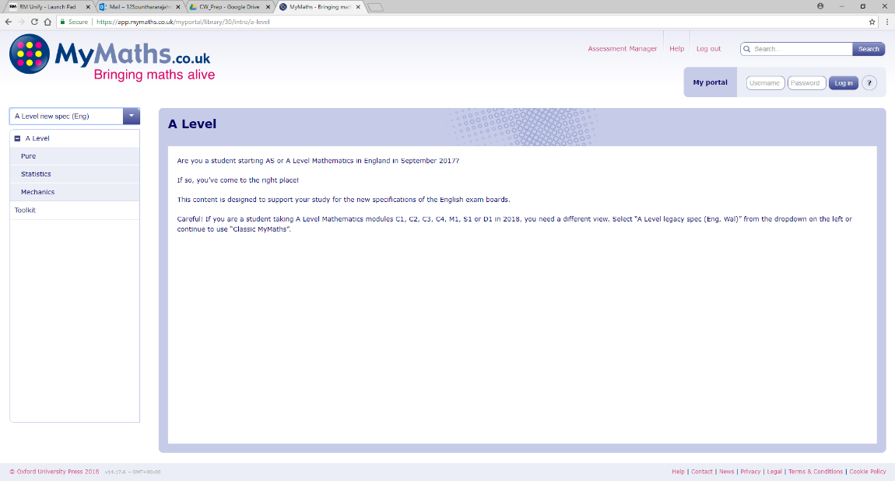After selecting the new A Level Mathematics Specification, the student is redirected to this portal. They are greeted with a screen informing them that the content is designed for the new specification and warns that Students taking C1-4, M1, S1 or D1 should use the legacy specification pages instead. This welcome design is very simplistic and so I would aim to make mine more functional whilst retaining minimalist qualities.



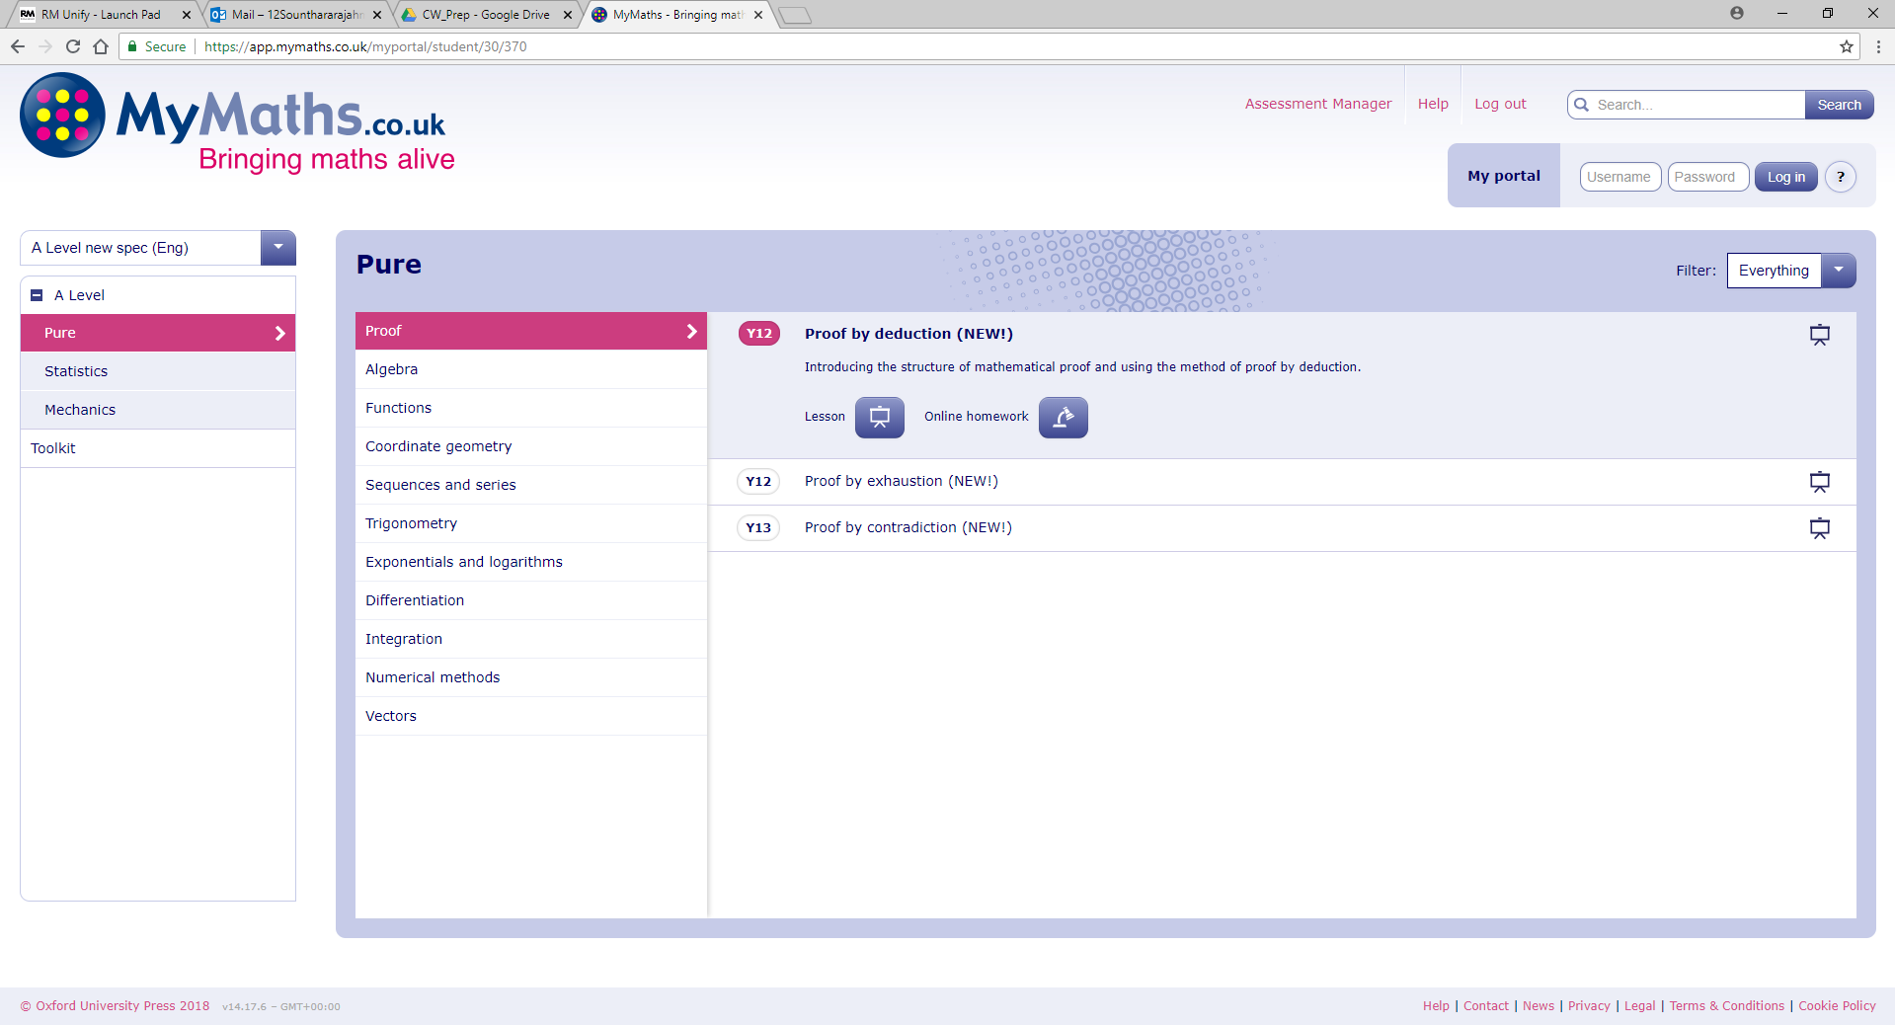Upon clicking on the adjacent tabs, in this case Pure, the student is greeted with the first topic in the first tab of the A Level library in the form of a lesson to learn or homework to do exercises.



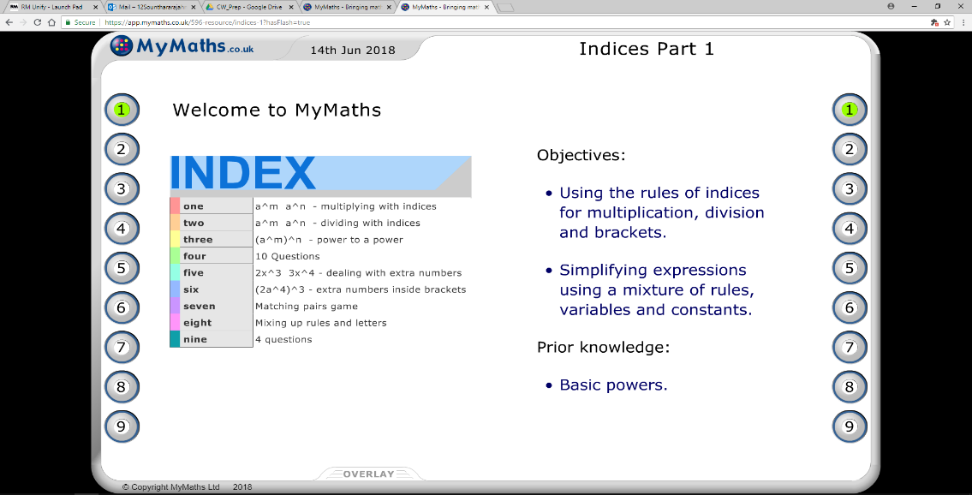If the student chooses to do a lesson, then it is opened in a new tab. There is index of all the things in the lesson for the student to complete. If the student opens multiple lessons, then lots of tabs are made which may take up too much RAM causing the students revision to be disrupted. This could be improved by integrating the lesson in the same window.



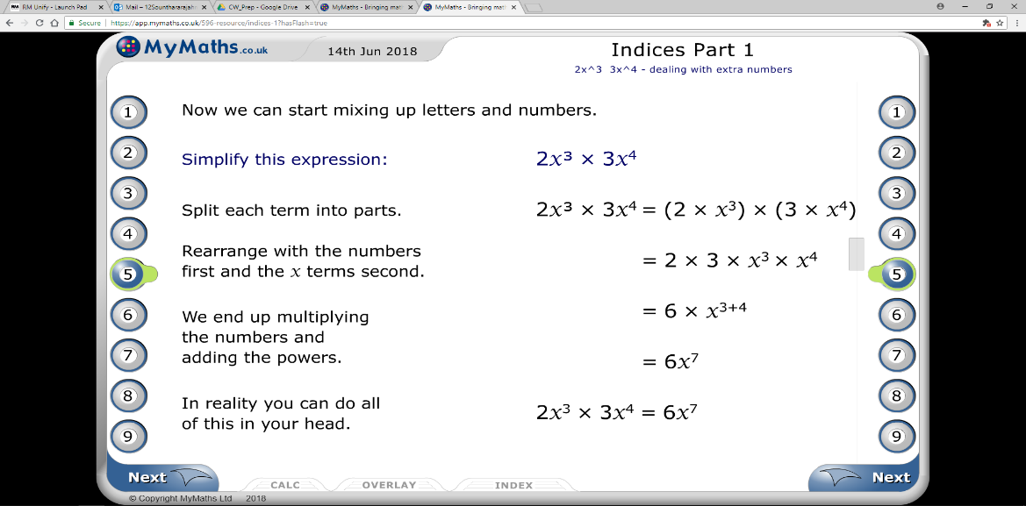The student can then go at their own pace with clear explanations on the method used to solve questions in this topic



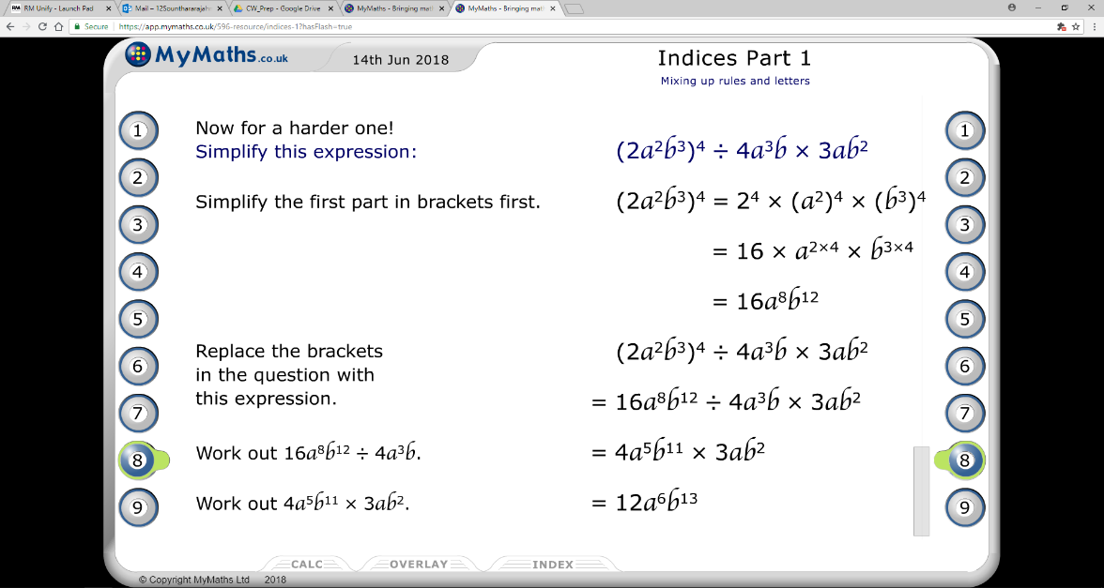There are also parts in which students can answer questions. This means that lessons can become very tedious which discourages revision despite their usefulness due to their thoroughness.

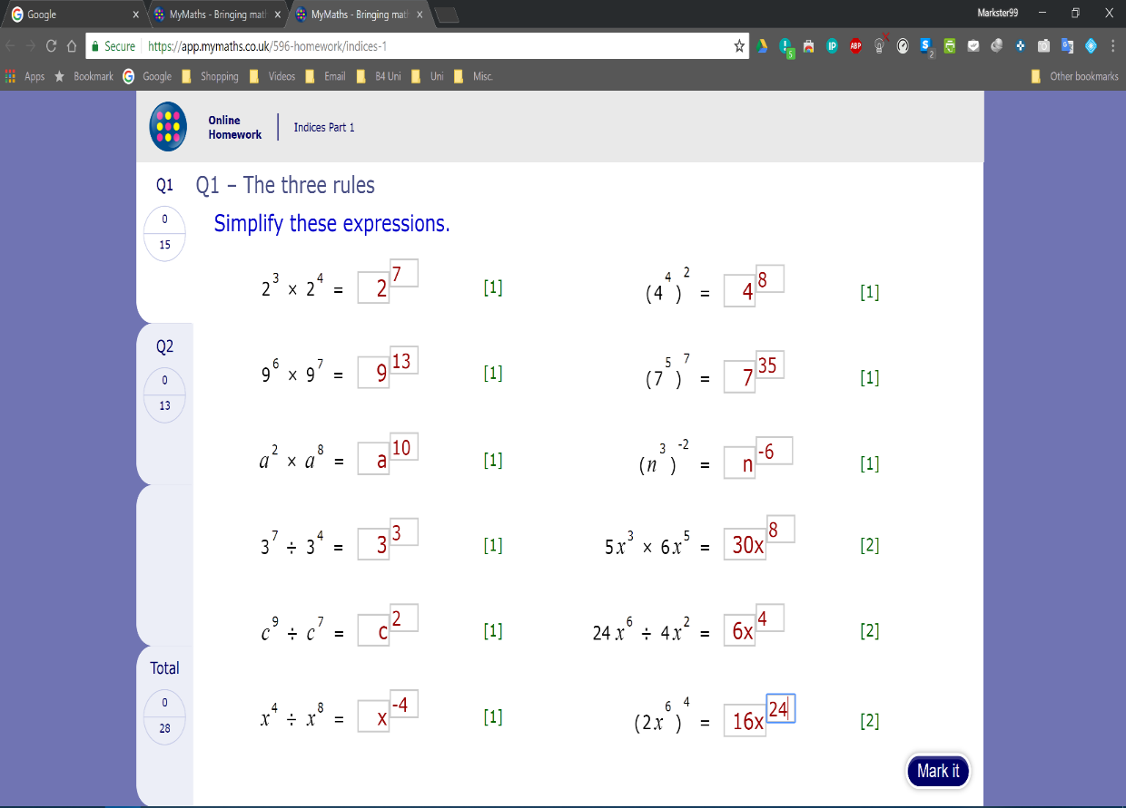

Alternatively, the student can choose to do a homework. These consist of questions which can be immediately marked to provide quick feedback. The questions have blank boxes, which are filled in right now to indicate their location, with mark allocations beside them.



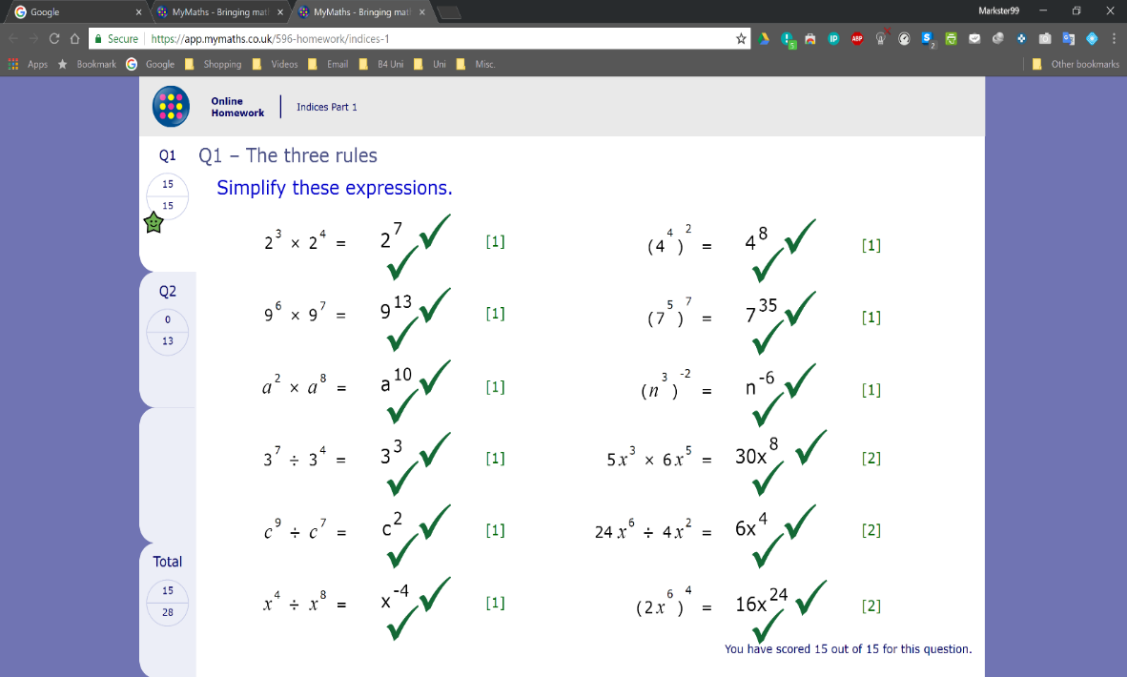After finishing the questions, the student can press the “Markit” button in the bottom left corner originally to receive instantaneous feedback on the completed questions on the page. After marking answers cannot be adjusted without redoing the homework.



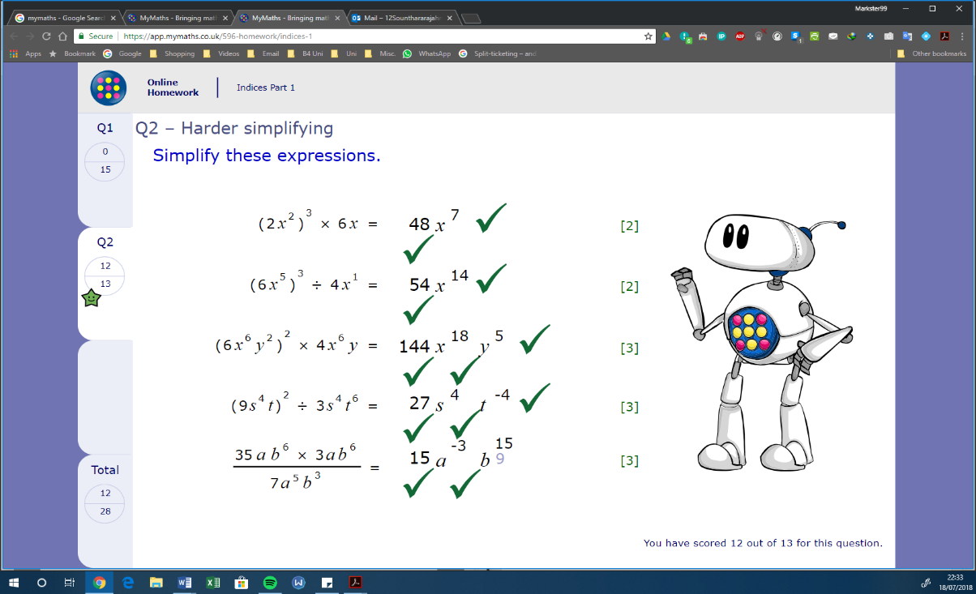

If a student makes a mistake whilst doing one of the questions, then the correct solution is displayed underneath as showcased by the second last question. This could be improved upon by showing where the student lost their marks specifically as on longer questions the mark allocation becomes more complicated to see.



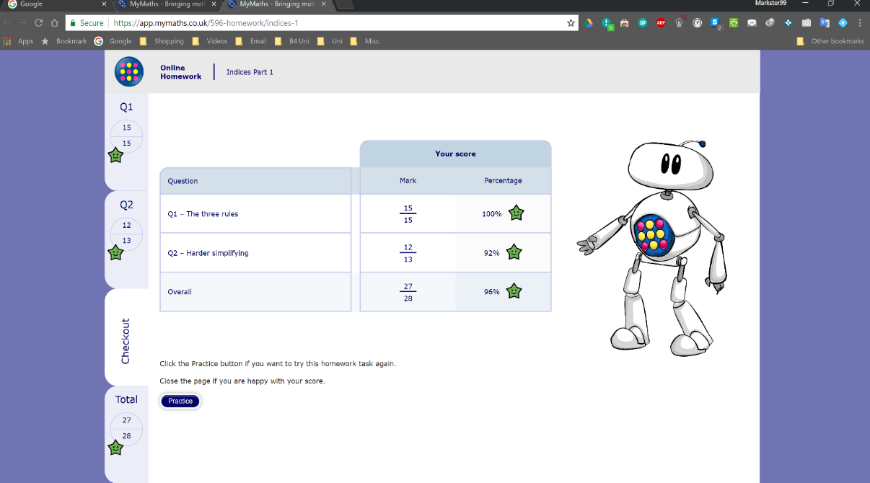 Upon completion of both sections of the homework the student is taken to a “Checkout”. This area shows their results for each section with the mark count as well as percentages. These are used to present green, orange or red stars to show the students' progress. If they are unhappy with their result or just want to practice, then they can redo the homework by clicking on the practice button which is near the bottom left corner.



# Conclusion

MyMaths includes a plethora of features which make it a great A Level revision resource from its instant feedback allowing students to recap mistakes quickly to its breakdown of questions into their topics and from their subtopics allowing students access to specialist assistance. Despite the great prior features, without the teacher intervention of making accounts and setting homework tasks, students are unable to individually focus on certain tasks due to the inability to set personal deadlines which I would attempt to implement.

Also, students who are unable to keep track of all the lessons and homework tasks they’re opening may accidently close an important tab out of the many created which is why it should be enclosed within a single window. In Conclusion, MyMaths is a very useful aid for student revision but its reliance upon teachers is not particularly preferred.

Isaac Physics

# Introduction

Isaac Physics is a physics revision website currently used by some state students in UK Secondary Schools using it. It does not require a. It includes GCSE and quite a lot of the A Level in Mathematics. My School has been using Isaac Physics somewhat recently. I shall be exploring some of the features that I believe are key to the status of Isaac Physics as a widely used online physics resource online due to its’ accessibility for students despite some its less helpful features which I will be scrutinizing to create a better summative revision resource.

Review

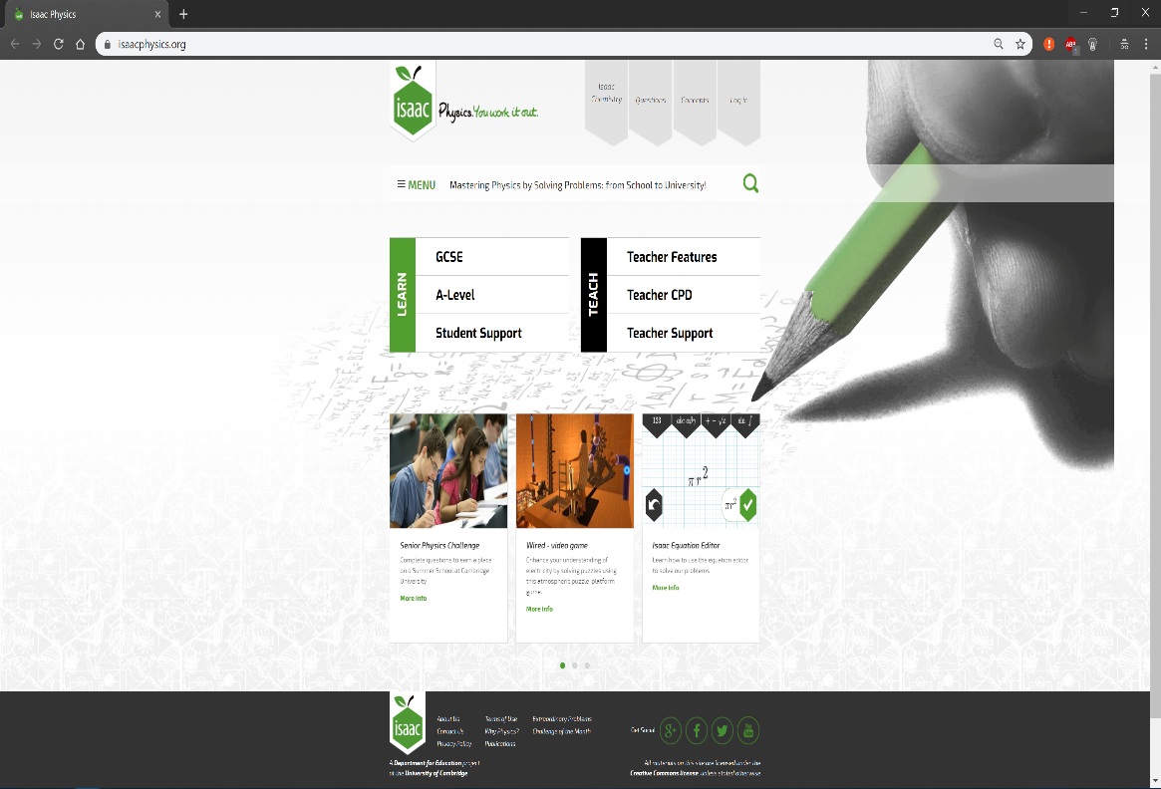

Upon loading isaacphysics.org you are greeted with a welcome screen. It has tabs indicating whatever information is required. In the top right corner, there is a Log In bottom which uses login details made by the user.



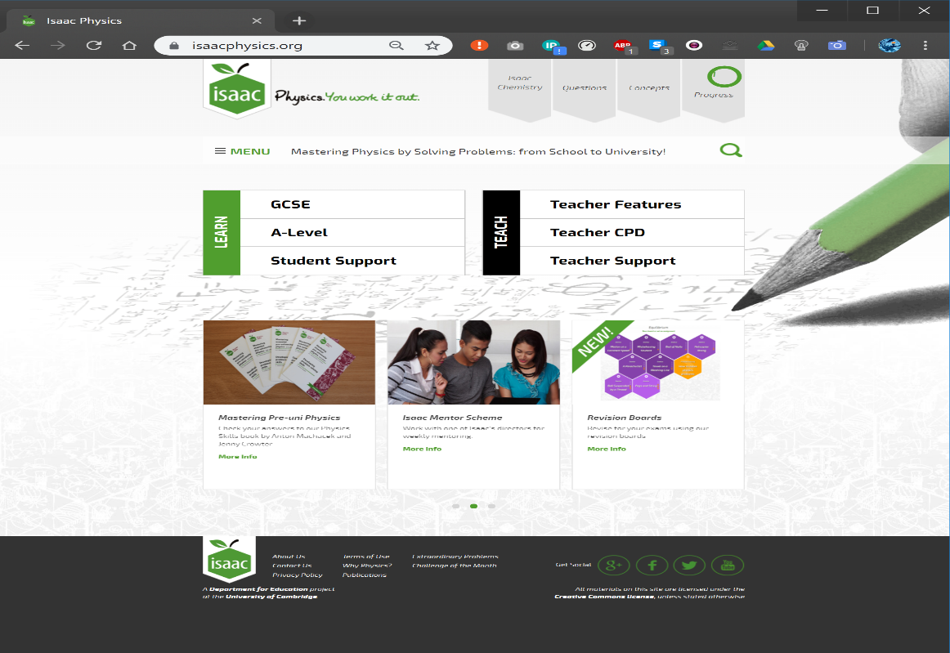After logging in with your username and password, you are ushered back to the main portal; The login button has now been replaced by a progress button.



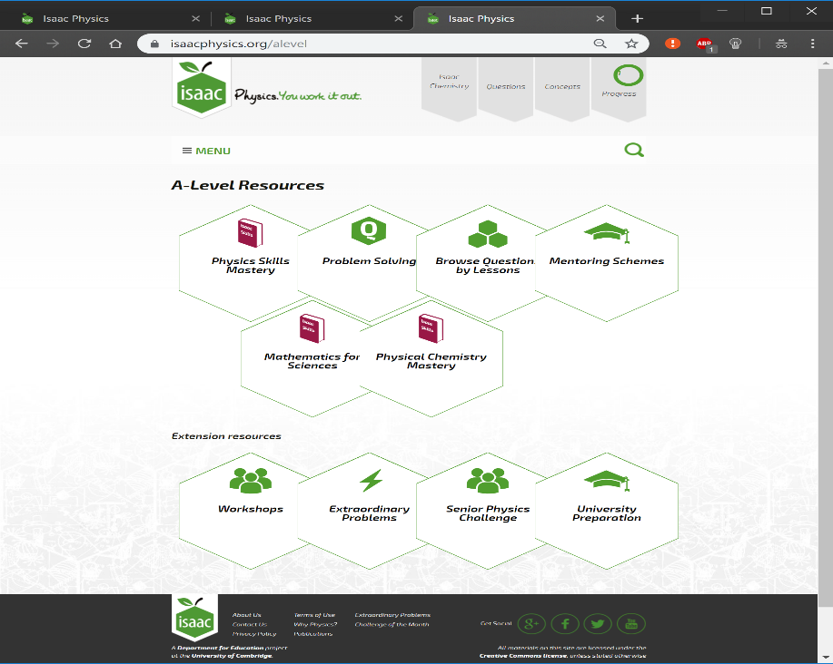After selecting the A Level option, the student is redirected to this portal. They are greeted with a screen informing them of the resources available and any extension resources.

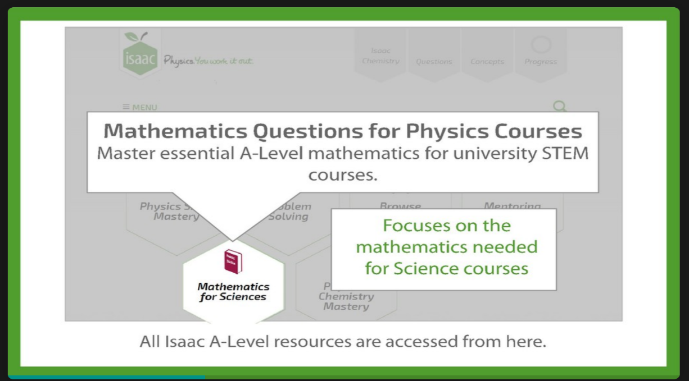

This welcome design is very simplistic and so I would aim to make mine more functional whilst retaining minimalist qualities.

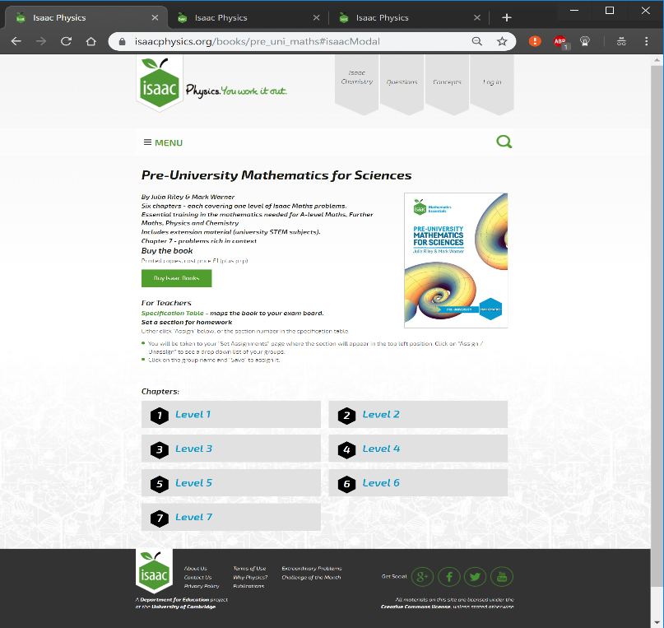After selecting the Mathematics for Sciences section, the student is redirected to this portal. They are greeted with a screen informing them that the content is split into 7 levels.

They are also able to purchase a book, for £1 with £2.50 for Postage and Packaging. It has six chapters covering the 6 levels of Math problems from Isaac where they can be answered on-line. The material provides essential training in the mathematics needed for A-level Math, Further Math, Physics and Chemistry, and extends to the first year at university in these subjects plus Engineering. Chapter 7 gives additional material with applications to sciences, some of which comes from the Isaac Physics extension problems collection.

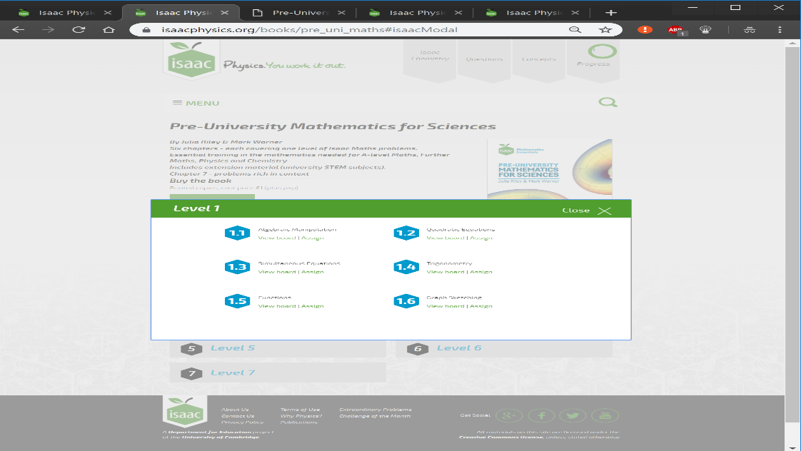After selecting the Level 1 section, the student is redirected to this portal. They are greeted with a screen informing them that the content is split into 6 Sections.

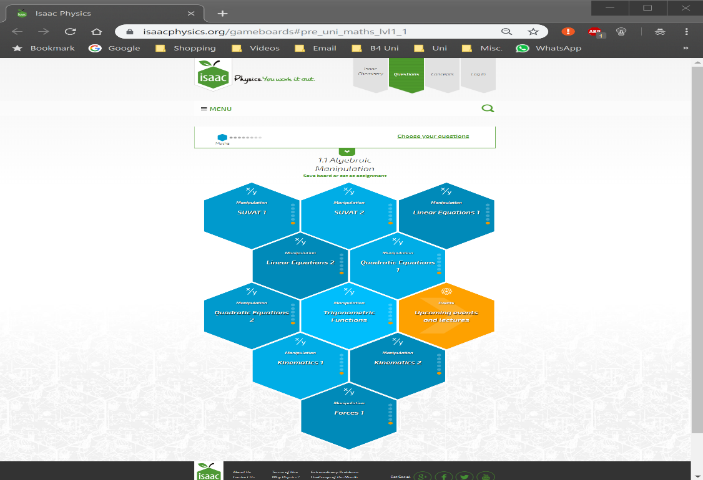

After selecting the view board link under 1.1 section, the student is redirected to this portal. They are greeted with a screen informing them that the content is split into 10 Sections plus a section for events.

DRAFT CODE

INDEX.HTML

<!DOCTYPE html>

<html lang="en-UK">

<meta charset="UTF-8">

<meta content="width=device-width, initial-scale=1" name="viewport">

<link href="style.css" rel="stylesheet" type="text/css">

<head>

<title>Arctic Math</title>

</head>

<div id="g-signin">

<script async defer src="https://apis.google.com/js/platform.js"></script>

<meta content="profile email" name="google-signin-scope">

<meta content="215405045709-h89405dp4slh64sfdli5903i881a1flq.apps.googleusercontent.com"

name="google-signin-client_id">

<script async defer src="https://apis.google.com/js/platform.js"></script>

<div class="g-signin" data-onsuccess="onSignIn" data-theme="dark"></div>

</div>

//google Log in

<body>

<h1>Hello Mathematicians :)</h1>

<hr/>

<br>

<p>Welcome to a great study resource for any A Level Mathematician

<br><strong>as well as</strong><br> for anyone looking for extension/revision work.

</p>

<br>

<a href="ALevelMathematics/Quadratic Equation/Quadratic Equations.html" target="_blank"

title="Go to Quadratic Equations">Quadratic Equations</a>

</body>

<h2>Copyright &copy; 2018 Mark R. Sounthararajah</h2>

</html>

STYLE.CSS

title {

font-family: "Cambria Math";

/*background-color: #000000;*/

}

body {

background-color: floralwhite;

/*background-image: url("MathFrontCover.jpg");*/

}

#g-signin {

margin-left:40px;

margin-top: auto;

margin-right: auto;

}

h1 {

color: lightblue;

text-align: center;

margin-left: auto;

margin-right: auto;

}

h2 {

text-align: center;

}

p {

color: darkblue;

text-align: center;

}

QUADRATIC EQUATIONS.HTML

<?php

$root1 = $_POST["root1"];

$root2 = $_POST["root2"];

?>

<!DOCTYPE html>

<html lang="en">

<head>

<meta charset="UTF-8">

<title>Quadratic Equations</title>

</head>

<body>

</body>

</html>

QUADEQN.PHP

<?php

function inputRoots()

{

$d = $GLOBALS['d'];

if ($d = 0) {

echo 'What do think x is ? ';

$userRoot1 = rtrim(fgets(STDIN));

echo 'I got x = ' . $userRoot1;

} else //If the discriminant is greater than 0 i.e. The quadratic equation has 2 distinct real roots

{

echo 'What do think a value of x is ? ';

$userRoot1 = rtrim(fgets(STDIN));

echo 'I got your 1st value of x = ' . $userRoot1;

echo 'What do think another value of x is ? ';

$userRoot2 = rtrim(fgets(STDIN));

echo 'I got your 2nd value of x = ' . $userRoot2;

}

}

//This stores the users submitted possible roots to the quadratic equation Make this into a pop up window or button

function verifyRoots()

{

$d = $GLOBALS['d'];

if ($d = 0) {

if ($GLOBALS['userRoot1'] = $GLOBALS['R1']) {

echo "Well Done. You've successfully solved the quadratic equation : " . $GLOBALS['equation'];

} else {

echo 'Unfortunately your answer was incorrect. The correct value was ' . $GLOBALS('R1');

}

}//only one possible solution

else if ($d > 0) {

if ((($GLOBALS['userRoot1'] = $GLOBALS['R1']) && ($GLOBALS['userRoot2'] = $GLOBALS['R2'])) || (($GLOBALS['userRoot1'] = $GLOBALS['R2']) && ($GLOBALS['userRoot2'] = $GLOBALS['R1']))) {

echo "Well Done. You've successfully solved the quadratic equation : " . $GLOBALS['equation'];

}//both solutions are correct

} else if ((($GLOBALS['userRoot1'] = $GLOBALS['R1']) || ($GLOBALS['userRoot2'] = $GLOBALS['R2'])) xor (($GLOBALS['userRoot1'] = $GLOBALS['R2']) || ($GLOBALS['userRoot2'] = $GLOBALS['R1']))) {

echo "Almost there. You've successfully solved the quadratic equation : " . $GLOBALS['equation'];

if ($GLOBALS['userRoot1'] = $GLOBALS['R1']) {

echo $GLOBALS['userRoot1'] . ' was correct. Unfortunately your second answer was wrong. The second root of ' . $GLOBALS['equation'] . ' was ' . $GLOBALS['R2'];

} else if ($GLOBALS['userRoot1'] = $GLOBALS['R2']) {

echo $GLOBALS['userRoot1'] . ' was correct. Unfortunately your second answer was wrong. The second root of ' . $GLOBALS['equation'] . ' was ' . $GLOBALS['R1'];

} else if ($GLOBALS['userRoot2'] = $GLOBALS['R1']) {

echo $GLOBALS['userRoot2'] . ' was correct. Unfortunately your second answer was wrong. The second root of ' . $GLOBALS['equation'] . ' was ' . $GLOBALS['R2'];

} else if ($GLOBALS['userRoot2'] = $GLOBALS['R2']) {

echo $GLOBALS['userRoot2'] . ' was correct. Unfortunately your second answer was wrong. The second root of ' . $GLOBALS['equation'] . ' was ' . $GLOBALS['R1'];

}

}//one solution is correct

else {

echo 'Unfortunately both ' . $GLOBALS['userRoot1'] . ' and ' . $GLOBALS['userRoot2'] . ' are incorrect answers to the equation ' . $GLOBALS['equation'] .' . The correct roots were ' . $GLOBALS['R1'] . ' and ' . $GLOBALS['R2'] . ' .';

}//no correct solutions

}

/* This checks the user roots against the actual roots and then shows messages apt to the validity of the provided User Roots*/

QUADRATICQUATIONS.PHP

<?php

include 'C:\Users\sount\IdeaProjects\Arctic Math\ReusableFunctions.php';

welcome('Quadratic Equations'); // This welcomes a user

$a = (double)0;

$b = (double)0;

$c = (double)0;

$d = (double)0;

do {

do {

try {

$a = random_int(-5, 5);

} catch (Exception $e) {

}

try {

$b = random_int(-10, 10);

} catch (Exception $e) {

}

try {

$c = random_int(-5, 5);

} catch (Exception $e) {

}

try {

$d = random_int(-10, 10);

} catch (Exception $e) {

}

} while ($a === 0 || $b === 0 || $c === 0 || $d === 0);//Start with (ax-b)(cx-d)=0

$a1 = $a * $c;

$b1 = -(($a * $d) + ($b * $c));

$c1 = $b * $d;

//Coefficients of the equation generated by the expansion of (ax-b)(cx-d)

$d1 = ($b1 ** 2) - (4 * $a1 * $c1);

//The discriminant of the newly generated equation

} while ($a1 === 0 || $b1 === 0 || $c1 === 0 || $d1 < 0);

$turning_point_prefix = 'The turning point of the quadratic equation is (';

$turning_point_suffix = '). This is a local ';

$x_turning_point = (-$b1) / (2 * $a1);

$y_turning_point = $c1 - (($b1 ** 2) / (4 * $a1));

$type_of_turning_point = 'turning point of the quadratic equation.';

$concavity = 2 * $a1;//The coefficient of x in the gradient or the 2nd Derivative

if ($concavity > 0) {

$type_of_turning_point = 'minimum.';

} else if ($concavity < 0) {

$type_of_turning_point = 'maximum.';

}

$turning_point = "\r\n" . $turning_point_prefix . $x_turning_point . ',' . $y_turning_point . $turning_point_suffix . $type_of_turning_point;

$root1 = $b / $a;

$root2 = $d / $c;

if ($root1 !== $root2) {

$roots = array($root1, $root2);

$root_type = 'This quadratic equation has 2 distinct real roots.';

$equation_suffix = 'Find the values of x when y crosses the x-axis.';

} else {

$roots = array($root1);//This is the repeated root

$root_type = 'This quadratic equation has a single repeated real root.';

$equation_suffix = 'Find the value of x when y crosses the x-axis.';

}// Root Type could be implemented as a hint

$a3 = format1stCoe($a1);

$b3 = format1stCoe($b1);

$c3 = format1stCoe($c1);

$b3 = formatNum($b1);

$c3 = formatNum($c1);

$gradient = $concavity . 'x ' . $b3;

$equation = 'y = ' . $a3 . 'x^2 ' . $b3 . 'x ' . $c3 . "\r\n";

$bar = '----------------------------------------------------------------------------------';

echo $equation;

/* This generates a valid quadratic equation as well as a hint and its roots*/

//if user is wrong

if($d1===0){

$Working2=$a.'x ='.$b;

$working3='x ='.($b/$a);

$a2 = format1stCoe($a);

$c2 = format1stCoe($c);

$b2= formatNum($b);

$d2= formatNum($d);

$FactorisedEquation='('.$a2.'x'.$b2.')^2';

$Working='('.$a1.'x'.$b1.')=0';

}

else {

$a2 = format1stCoe($a);

$c2 = format1stCoe($c);

$b2= formatNum($b);

$d2= formatNum($d);

$FactorisedEquation='('.$a2.'x'.$b2.')('.$c2.'x'.$d2.')';

$Working='('.$a1.'x'.$b1.') =0 or ('.$c1.'x'.$d1.')=0';

}

echo "\r\n".'Unfortunately you did not solve '.$equation. 'When you factorise the equation you get '.$FactorisedEquation.'.';

echo "\r\n".'When the equation crosses the x axis , y=0';

echo "\r\n".$Working;

REUSABLEFUNCTIONS.PHP

<?php

function welcome($welcome)

{

echo "I hope you'll enjoy learning about " . $welcome . " \r\n";

//have sql to pull in info from a Database or Spec about topic using $_SERVER['PHP_SELF']

}

/*This announces the topic.*/

function formatNum($num)

{

if ($num > 0) {

$num = sprintf('%+d', $num);

return $num;

}

return $num;

}

//Make all positive variables show a plus sign

function format1stCoe($num)

{

if ($num === 1) {

$num = '';

return $num;

}

if ($num === -1) {

$num = '- ';

return $num;

}

return $num;

}

//Make all values of 1 turn into sole minus or blank space

DRAFT CODE

INDEX.HTML

<!DOCTYPE html>

<html lang="en-UK">

<meta charset="UTF-8">

<meta content="width=device-width, initial-scale=1" name="viewport">

<link href="style.css" rel="stylesheet" type="text/css">

<head>

<title>Arctic Math</title>

</head>

<div id="g-signin">

<script async defer src="https://apis.google.com/js/platform.js"></script>

<meta content="profile email" name="google-signin-scope">

<meta content="215405045709-h89405dp4slh64sfdli5903i881a1flq.apps.googleusercontent.com"

name="google-signin-client_id">

<script async defer src="https://apis.google.com/js/platform.js"></script>

<div class="g-signin" data-onsuccess="onSignIn" data-theme="dark"></div>

</div>

//google Log in

<body>

<h1>Hello Mathematicians :)</h1>

<hr/>

<br>

<p>Welcome to a great study resource for any A Level Mathematician

<br><strong>as well as</strong><br> for anyone looking for extension/revision work.

</p>

<br>

<a href="ALevelMathematics/Quadratic Equation/Quadratic Equations.html" target="_blank"

title="Go to Quadratic Equations">Quadratic Equations</a>

</body>

<h2>Copyright &copy; 2018 Mark R. Sounthararajah</h2>

</html>

STYLE.CSS

title {

font-family: "Cambria Math";

/*background-color: #000000;*/

}

body {

background-color: floralwhite;

/*background-image: url("MathFrontCover.jpg");*/

}

#g-signin {

margin-left:40px;

margin-top: auto;

margin-right: auto;

}

h1 {

color: lightblue;

text-align: center;

margin-left: auto;

margin-right: auto;

}

h2 {

text-align: center;

}

p {

color: darkblue;

text-align: center;

}

QUADRATIC EQUATIONS.HTML

<?php

$root1 = $_POST["root1"];

$root2 = $_POST["root2"];

?>

<!DOCTYPE html>

<html lang="en">

<head>

<meta charset="UTF-8">

<title>Quadratic Equations</title>

</head>

<body>

</body>

</html>

QUADEQN.PHP

<?php

function inputRoots()

{

$d = $GLOBALS['d'];

if ($d = 0) {

echo 'What do think x is ? ';

$userRoot1 = rtrim(fgets(STDIN));

echo 'I got x = ' . $userRoot1;

} else //If the discriminant is greater than 0 i.e. The quadratic equation has 2 distinct real roots

{

echo 'What do think a value of x is ? ';

$userRoot1 = rtrim(fgets(STDIN));

echo 'I got your 1st value of x = ' . $userRoot1;

echo 'What do think another value of x is ? ';

$userRoot2 = rtrim(fgets(STDIN));

echo 'I got your 2nd value of x = ' . $userRoot2;

}

}

//This stores the users submitted possible roots to the quadratic equation Make this into a pop up window or button

function verifyRoots()

{

$d = $GLOBALS['d'];

if ($d = 0) {

if ($GLOBALS['userRoot1'] = $GLOBALS['R1']) {

echo "Well Done. You've successfully solved the quadratic equation : " . $GLOBALS['equation'];

} else {

echo 'Unfortunately your answer was incorrect. The correct value was ' . $GLOBALS('R1');

}

}//only one possible solution

else if ($d > 0) {

if ((($GLOBALS['userRoot1'] = $GLOBALS['R1']) && ($GLOBALS['userRoot2'] = $GLOBALS['R2'])) || (($GLOBALS['userRoot1'] = $GLOBALS['R2']) && ($GLOBALS['userRoot2'] = $GLOBALS['R1']))) {

echo "Well Done. You've successfully solved the quadratic equation : " . $GLOBALS['equation'];

}//both solutions are correct

} else if ((($GLOBALS['userRoot1'] = $GLOBALS['R1']) || ($GLOBALS['userRoot2'] = $GLOBALS['R2'])) xor (($GLOBALS['userRoot1'] = $GLOBALS['R2']) || ($GLOBALS['userRoot2'] = $GLOBALS['R1']))) {

echo "Almost there. You've successfully solved the quadratic equation : " . $GLOBALS['equation'];

if ($GLOBALS['userRoot1'] = $GLOBALS['R1']) {

echo $GLOBALS['userRoot1'] . ' was correct. Unfortunately your second answer was wrong. The second root of ' . $GLOBALS['equation'] . ' was ' . $GLOBALS['R2'];

} else if ($GLOBALS['userRoot1'] = $GLOBALS['R2']) {

echo $GLOBALS['userRoot1'] . ' was correct. Unfortunately your second answer was wrong. The second root of ' . $GLOBALS['equation'] . ' was ' . $GLOBALS['R1'];

} else if ($GLOBALS['userRoot2'] = $GLOBALS['R1']) {

echo $GLOBALS['userRoot2'] . ' was correct. Unfortunately your second answer was wrong. The second root of ' . $GLOBALS['equation'] . ' was ' . $GLOBALS['R2'];

} else if ($GLOBALS['userRoot2'] = $GLOBALS['R2']) {

echo $GLOBALS['userRoot2'] . ' was correct. Unfortunately your second answer was wrong. The second root of ' . $GLOBALS['equation'] . ' was ' . $GLOBALS['R1'];

}

}//one solution is correct

else {

echo 'Unfortunately both ' . $GLOBALS['userRoot1'] . ' and ' . $GLOBALS['userRoot2'] . ' are incorrect answers to the equation ' . $GLOBALS['equation'] .' . The correct roots were ' . $GLOBALS['R1'] . ' and ' . $GLOBALS['R2'] . ' .';

}//no correct solutions

}

/* This checks the user roots against the actual roots and then shows messages apt to the validity of the provided User Roots*/

QUADRATICQUATIONS.PHP

<?php

include 'C:\Users\sount\IdeaProjects\Arctic Math\ReusableFunctions.php';

welcome('Quadratic Equations'); // This welcomes a user

$a = (double)0;

$b = (double)0;

$c = (double)0;

$d = (double)0;

do {

do {

try {

$a = random_int(-5, 5);

} catch (Exception $e) {

}

try {

$b = random_int(-10, 10);

} catch (Exception $e) {

}

try {

$c = random_int(-5, 5);

} catch (Exception $e) {

}

try {

$d = random_int(-10, 10);

} catch (Exception $e) {

}

} while ($a === 0 || $b === 0 || $c === 0 || $d === 0);//Start with (ax-b)(cx-d)=0

$a1 = $a * $c;

$b1 = -(($a * $d) + ($b * $c));

$c1 = $b * $d;

//Coefficients of the equation generated by the expansion of (ax-b)(cx-d)

$d1 = ($b1 ** 2) - (4 * $a1 * $c1);

//The discriminant of the newly generated equation

} while ($a1 === 0 || $b1 === 0 || $c1 === 0 || $d1 < 0);

$turning_point_prefix = 'The turning point of the quadratic equation is (';

$turning_point_suffix = '). This is a local ';

$x_turning_point = (-$b1) / (2 * $a1);

$y_turning_point = $c1 - (($b1 ** 2) / (4 * $a1));

$type_of_turning_point = 'turning point of the quadratic equation.';

$concavity = 2 * $a1;//The coefficient of x in the gradient or the 2nd Derivative

if ($concavity > 0) {

$type_of_turning_point = 'minimum.';

} else if ($concavity < 0) {

$type_of_turning_point = 'maximum.';

}

$turning_point = "\r\n" . $turning_point_prefix . $x_turning_point . ',' . $y_turning_point . $turning_point_suffix . $type_of_turning_point;

$root1 = $b / $a;

$root2 = $d / $c;

if ($root1 !== $root2) {

$roots = array($root1, $root2);

$root_type = 'This quadratic equation has 2 distinct real roots.';

$equation_suffix = 'Find the values of x when y crosses the x-axis.';

} else {

$roots = array($root1);//This is the repeated root

$root_type = 'This quadratic equation has a single repeated real root.';

$equation_suffix = 'Find the value of x when y crosses the x-axis.';

}// Root Type could be implemented as a hint

$a3 = format1stCoe($a1);

$b3 = format1stCoe($b1);

$c3 = format1stCoe($c1);

$b3 = formatNum($b1);

$c3 = formatNum($c1);

$gradient = $concavity . 'x ' . $b3;

$equation = 'y = ' . $a3 . 'x^2 ' . $b3 . 'x ' . $c3 . "\r\n";

$bar = '----------------------------------------------------------------------------------';

echo $equation;

/* This generates a valid quadratic equation as well as a hint and its roots*/

//if user is wrong

if($d1===0){

$Working2=$a.'x ='.$b;

$working3='x ='.($b/$a);

$a2 = format1stCoe($a);

$c2 = format1stCoe($c);

$b2= formatNum($b);

$d2= formatNum($d);

$FactorisedEquation='('.$a2.'x'.$b2.')^2';

$Working='('.$a1.'x'.$b1.')=0';

}

else {

$a2 = format1stCoe($a);

$c2 = format1stCoe($c);

$b2= formatNum($b);

$d2= formatNum($d);

$FactorisedEquation='('.$a2.'x'.$b2.')('.$c2.'x'.$d2.')';

$Working='('.$a1.'x'.$b1.') =0 or ('.$c1.'x'.$d1.')=0';

}

echo "\r\n".'Unfortunately you did not solve '.$equation. 'When you factorise the equation you get '.$FactorisedEquation.'.';

echo "\r\n".'When the equation crosses the x axis , y=0';

echo "\r\n".$Working;

REUSABLEFUNCTIONS.PHP

<?php

function welcome($welcome)

{

echo "I hope you'll enjoy learning about " . $welcome . " \r\n";

//have sql to pull in info from a Database or Spec about topic using $_SERVER['PHP_SELF']

}

/*This announces the topic.*/

function formatNum($num)

{

if ($num > 0) {

$num = sprintf('%+d', $num);

return $num;

}

return $num;

}

//Make all positive variables show a plus sign

function format1stCoe($num)

{

if ($num === 1) {

$num = '';

return $num;

}

if ($num === -1) {

$num = '- ';

return $num;

}

return $num;

}

//Make all values of 1 turn into sole minus or blank space

DRAFT CODE

INDEX.HTML

<!DOCTYPE html>

<html lang="en-UK">

<meta charset="UTF-8">

<meta content="width=device-width, initial-scale=1" name="viewport">

<link href="style.css" rel="stylesheet" type="text/css">

<head>

<title>Arctic Math</title>

</head>

<div id="g-signin">

<script async defer src="https://apis.google.com/js/platform.js"></script>

<meta content="profile email" name="google-signin-scope">

<meta content="215405045709-h89405dp4slh64sfdli5903i881a1flq.apps.googleusercontent.com"

name="google-signin-client_id">

<script async defer src="https://apis.google.com/js/platform.js"></script>

<div class="g-signin" data-onsuccess="onSignIn" data-theme="dark"></div>

</div>

//google Log in

<body>

<h1>Hello Mathematicians :)</h1>

<hr/>

<br>

<p>Welcome to a great study resource for any A Level Mathematician

<br><strong>as well as</strong><br> for anyone looking for extension/revision work.

</p>

<br>

<a href="ALevelMathematics/Quadratic Equation/Quadratic Equations.html" target="_blank"

title="Go to Quadratic Equations">Quadratic Equations</a>

</body>

<h2>Copyright &copy; 2018 Mark R. Sounthararajah</h2>

</html>

STYLE.CSS

title {

font-family: "Cambria Math";

/*background-color: #000000;*/

}

body {

background-color: floralwhite;

/*background-image: url("MathFrontCover.jpg");*/

}

#g-signin {

margin-left:40px;

margin-top: auto;

margin-right: auto;

}

h1 {

color: lightblue;

text-align: center;

margin-left: auto;

margin-right: auto;

}

h2 {

text-align: center;

}

p {

color: darkblue;

text-align: center;

}

QUADRATIC EQUATIONS.HTML

<?php

$root1 = $_POST["root1"];

$root2 = $_POST["root2"];

?>

<!DOCTYPE html>

<html lang="en">

<head>

<meta charset="UTF-8">

<title>Quadratic Equations</title>

</head>

<body>

</body>

</html>

QUADEQN.PHP

<?php

function inputRoots()

{

$d = $GLOBALS['d'];

if ($d = 0) {

echo 'What do think x is ? ';

$userRoot1 = rtrim(fgets(STDIN));

echo 'I got x = ' . $userRoot1;

} else //If the discriminant is greater than 0 i.e. The quadratic equation has 2 distinct real roots

{

echo 'What do think a value of x is ? ';

$userRoot1 = rtrim(fgets(STDIN));

echo 'I got your 1st value of x = ' . $userRoot1;

echo 'What do think another value of x is ? ';

$userRoot2 = rtrim(fgets(STDIN));

echo 'I got your 2nd value of x = ' . $userRoot2;

}

}

//This stores the users submitted possible roots to the quadratic equation Make this into a pop up window or button

function verifyRoots()

{

$d = $GLOBALS['d'];

if ($d = 0) {

if ($GLOBALS['userRoot1'] = $GLOBALS['R1']) {

echo "Well Done. You've successfully solved the quadratic equation : " . $GLOBALS['equation'];

} else {

echo 'Unfortunately your answer was incorrect. The correct value was ' . $GLOBALS('R1');

}

}//only one possible solution

else if ($d > 0) {

if ((($GLOBALS['userRoot1'] = $GLOBALS['R1']) && ($GLOBALS['userRoot2'] = $GLOBALS['R2'])) || (($GLOBALS['userRoot1'] = $GLOBALS['R2']) && ($GLOBALS['userRoot2'] = $GLOBALS['R1']))) {

echo "Well Done. You've successfully solved the quadratic equation : " . $GLOBALS['equation'];

}//both solutions are correct

} else if ((($GLOBALS['userRoot1'] = $GLOBALS['R1']) || ($GLOBALS['userRoot2'] = $GLOBALS['R2'])) xor (($GLOBALS['userRoot1'] = $GLOBALS['R2']) || ($GLOBALS['userRoot2'] = $GLOBALS['R1']))) {

echo "Almost there. You've successfully solved the quadratic equation : " . $GLOBALS['equation'];

if ($GLOBALS['userRoot1'] = $GLOBALS['R1']) {

echo $GLOBALS['userRoot1'] . ' was correct. Unfortunately your second answer was wrong. The second root of ' . $GLOBALS['equation'] . ' was ' . $GLOBALS['R2'];

} else if ($GLOBALS['userRoot1'] = $GLOBALS['R2']) {

echo $GLOBALS['userRoot1'] . ' was correct. Unfortunately your second answer was wrong. The second root of ' . $GLOBALS['equation'] . ' was ' . $GLOBALS['R1'];

} else if ($GLOBALS['userRoot2'] = $GLOBALS['R1']) {

echo $GLOBALS['userRoot2'] . ' was correct. Unfortunately your second answer was wrong. The second root of ' . $GLOBALS['equation'] . ' was ' . $GLOBALS['R2'];

} else if ($GLOBALS['userRoot2'] = $GLOBALS['R2']) {

echo $GLOBALS['userRoot2'] . ' was correct. Unfortunately your second answer was wrong. The second root of ' . $GLOBALS['equation'] . ' was ' . $GLOBALS['R1'];

}

}//one solution is correct

else {

echo 'Unfortunately both ' . $GLOBALS['userRoot1'] . ' and ' . $GLOBALS['userRoot2'] . ' are incorrect answers to the equation ' . $GLOBALS['equation'] .' . The correct roots were ' . $GLOBALS['R1'] . ' and ' . $GLOBALS['R2'] . ' .';

}//no correct solutions

}

/* This checks the user roots against the actual roots and then shows messages apt to the validity of the provided User Roots*/

QUADRATICQUATIONS.PHP

<?php

include 'C:\Users\sount\IdeaProjects\Arctic Math\ReusableFunctions.php';

welcome('Quadratic Equations'); // This welcomes a user

$a = (double)0;

$b = (double)0;

$c = (double)0;

$d = (double)0;

do {

do {

try {

$a = random_int(-5, 5);

} catch (Exception $e) {

}

try {

$b = random_int(-10, 10);

} catch (Exception $e) {

}

try {

$c = random_int(-5, 5);

} catch (Exception $e) {

}

try {

$d = random_int(-10, 10);

} catch (Exception $e) {

}

} while ($a === 0 || $b === 0 || $c === 0 || $d === 0);//Start with (ax-b)(cx-d)=0

$a1 = $a * $c;

$b1 = -(($a * $d) + ($b * $c));

$c1 = $b * $d;

//Coefficients of the equation generated by the expansion of (ax-b)(cx-d)

$d1 = ($b1 ** 2) - (4 * $a1 * $c1);

//The discriminant of the newly generated equation

} while ($a1 === 0 || $b1 === 0 || $c1 === 0 || $d1 < 0);

$turning_point_prefix = 'The turning point of the quadratic equation is (';

$turning_point_suffix = '). This is a local ';

$x_turning_point = (-$b1) / (2 * $a1);

$y_turning_point = $c1 - (($b1 ** 2) / (4 * $a1));

$type_of_turning_point = 'turning point of the quadratic equation.';

$concavity = 2 * $a1;//The coefficient of x in the gradient or the 2nd Derivative

if ($concavity > 0) {

$type_of_turning_point = 'minimum.';

} else if ($concavity < 0) {

$type_of_turning_point = 'maximum.';

}

$turning_point = "\r\n" . $turning_point_prefix . $x_turning_point . ',' . $y_turning_point . $turning_point_suffix . $type_of_turning_point;

$root1 = $b / $a;

$root2 = $d / $c;

if ($root1 !== $root2) {

$roots = array($root1, $root2);

$root_type = 'This quadratic equation has 2 distinct real roots.';

$equation_suffix = 'Find the values of x when y crosses the x-axis.';

} else {

$roots = array($root1);//This is the repeated root

$root_type = 'This quadratic equation has a single repeated real root.';

$equation_suffix = 'Find the value of x when y crosses the x-axis.';

}// Root Type could be implemented as a hint

$a3 = format1stCoe($a1);

$b3 = format1stCoe($b1);

$c3 = format1stCoe($c1);

$b3 = formatNum($b1);

$c3 = formatNum($c1);

$gradient = $concavity . 'x ' . $b3;

$equation = 'y = ' . $a3 . 'x^2 ' . $b3 . 'x ' . $c3 . "\r\n";

$bar = '----------------------------------------------------------------------------------';

echo $equation;

/* This generates a valid quadratic equation as well as a hint and its roots*/

//if user is wrong

if($d1===0){

$Working2=$a.'x ='.$b;

$working3='x ='.($b/$a);

$a2 = format1stCoe($a);

$c2 = format1stCoe($c);

$b2= formatNum($b);

$d2= formatNum($d);

$FactorisedEquation='('.$a2.'x'.$b2.')^2';

$Working='('.$a1.'x'.$b1.')=0';

}

else {

$a2 = format1stCoe($a);

$c2 = format1stCoe($c);

$b2= formatNum($b);

$d2= formatNum($d);

$FactorisedEquation='('.$a2.'x'.$b2.')('.$c2.'x'.$d2.')';

$Working='('.$a1.'x'.$b1.') =0 or ('.$c1.'x'.$d1.')=0';

}

echo "\r\n".'Unfortunately you did not solve '.$equation. 'When you factorise the equation you get '.$FactorisedEquation.'.';

echo "\r\n".'When the equation crosses the x axis , y=0';

echo "\r\n".$Working;

REUSABLEFUNCTIONS.PHP

<?php

function welcome($welcome)

{

echo "I hope you'll enjoy learning about " . $welcome . " \r\n";

//have sql to pull in info from a Database or Spec about topic using $_SERVER['PHP_SELF']

}

/*This announces the topic.*/

function formatNum($num)

{

if ($num > 0) {

$num = sprintf('%+d', $num);

return $num;

}

return $num;

}

//Make all positive variables show a plus sign

function format1stCoe($num)

{

if ($num === 1) {

$num = '';

return $num;

}

if ($num === -1) {

$num = '- ';

return $num;

}

return $num;

}

//Make all values of 1 turn into sole minus or blank space

DRAFT CODE

INDEX.HTML

<!DOCTYPE html>

<html lang="en-UK">

<meta charset="UTF-8">

<meta content="width=device-width, initial-scale=1" name="viewport">

<link href="style.css" rel="stylesheet" type="text/css">

<head>

<title>Arctic Math</title>

</head>

<div id="g-signin">

<script async defer src="https://apis.google.com/js/platform.js"></script>

<meta content="profile email" name="google-signin-scope">

<meta content="215405045709-h89405dp4slh64sfdli5903i881a1flq.apps.googleusercontent.com"

name="google-signin-client_id">

<script async defer src="https://apis.google.com/js/platform.js"></script>

<div class="g-signin" data-onsuccess="onSignIn" data-theme="dark"></div>

</div>

//google Log in

<body>

<h1>Hello Mathematicians :)</h1>

<hr/>

<br>

<p>Welcome to a great study resource for any A Level Mathematician

<br><strong>as well as</strong><br> for anyone looking for extension/revision work.

</p>

<br>

<a href="ALevelMathematics/Quadratic Equation/Quadratic Equations.html" target="_blank"

title="Go to Quadratic Equations">Quadratic Equations</a>

</body>

<h2>Copyright &copy; 2018 Mark R. Sounthararajah</h2>

</html>

STYLE.CSS

title {

font-family: "Cambria Math";

/*background-color: #000000;*/

}

body {

background-color: floralwhite;

/*background-image: url("MathFrontCover.jpg");*/

}

#g-signin {

margin-left:40px;

margin-top: auto;

margin-right: auto;

}

h1 {

color: lightblue;

text-align: center;

margin-left: auto;

margin-right: auto;

}

h2 {

text-align: center;

}

p {

color: darkblue;

text-align: center;

}

QUADRATIC EQUATIONS.HTML

<?php

$root1 = $_POST["root1"];

$root2 = $_POST["root2"];

?>

<!DOCTYPE html>

<html lang="en">

<head>

<meta charset="UTF-8">

<title>Quadratic Equations</title>

</head>

<body>

</body>

</html>

QUADEQN.PHP

<?php

function inputRoots()

{

$d = $GLOBALS['d'];

if ($d = 0) {

echo 'What do think x is ? ';

$userRoot1 = rtrim(fgets(STDIN));

echo 'I got x = ' . $userRoot1;

} else //If the discriminant is greater than 0 i.e. The quadratic equation has 2 distinct real roots

{

echo 'What do think a value of x is ? ';

$userRoot1 = rtrim(fgets(STDIN));

echo 'I got your 1st value of x = ' . $userRoot1;

echo 'What do think another value of x is ? ';

$userRoot2 = rtrim(fgets(STDIN));

echo 'I got your 2nd value of x = ' . $userRoot2;

}

}

//This stores the users submitted possible roots to the quadratic equation Make this into a pop up window or button

function verifyRoots()

{

$d = $GLOBALS['d'];

if ($d = 0) {

if ($GLOBALS['userRoot1'] = $GLOBALS['R1']) {

echo "Well Done. You've successfully solved the quadratic equation : " . $GLOBALS['equation'];

} else {

echo 'Unfortunately your answer was incorrect. The correct value was ' . $GLOBALS('R1');

}

}//only one possible solution

else if ($d > 0) {

if ((($GLOBALS['userRoot1'] = $GLOBALS['R1']) && ($GLOBALS['userRoot2'] = $GLOBALS['R2'])) || (($GLOBALS['userRoot1'] = $GLOBALS['R2']) && ($GLOBALS['userRoot2'] = $GLOBALS['R1']))) {

echo "Well Done. You've successfully solved the quadratic equation : " . $GLOBALS['equation'];

}//both solutions are correct

} else if ((($GLOBALS['userRoot1'] = $GLOBALS['R1']) || ($GLOBALS['userRoot2'] = $GLOBALS['R2'])) xor (($GLOBALS['userRoot1'] = $GLOBALS['R2']) || ($GLOBALS['userRoot2'] = $GLOBALS['R1']))) {

echo "Almost there. You've successfully solved the quadratic equation : " . $GLOBALS['equation'];

if ($GLOBALS['userRoot1'] = $GLOBALS['R1']) {

echo $GLOBALS['userRoot1'] . ' was correct. Unfortunately your second answer was wrong. The second root of ' . $GLOBALS['equation'] . ' was ' . $GLOBALS['R2'];

} else if ($GLOBALS['userRoot1'] = $GLOBALS['R2']) {

echo $GLOBALS['userRoot1'] . ' was correct. Unfortunately your second answer was wrong. The second root of ' . $GLOBALS['equation'] . ' was ' . $GLOBALS['R1'];

} else if ($GLOBALS['userRoot2'] = $GLOBALS['R1']) {

echo $GLOBALS['userRoot2'] . ' was correct. Unfortunately your second answer was wrong. The second root of ' . $GLOBALS['equation'] . ' was ' . $GLOBALS['R2'];

} else if ($GLOBALS['userRoot2'] = $GLOBALS['R2']) {

echo $GLOBALS['userRoot2'] . ' was correct. Unfortunately your second answer was wrong. The second root of ' . $GLOBALS['equation'] . ' was ' . $GLOBALS['R1'];

}

}//one solution is correct

else {

echo 'Unfortunately both ' . $GLOBALS['userRoot1'] . ' and ' . $GLOBALS['userRoot2'] . ' are incorrect answers to the equation ' . $GLOBALS['equation'] .' . The correct roots were ' . $GLOBALS['R1'] . ' and ' . $GLOBALS['R2'] . ' .';

}//no correct solutions

}

/* This checks the user roots against the actual roots and then shows messages apt to the validity of the provided User Roots*/

QUADRATICQUATIONS.PHP

<?php

include 'C:\Users\sount\IdeaProjects\Arctic Math\ReusableFunctions.php';

welcome('Quadratic Equations'); // This welcomes a user

$a = (double)0;

$b = (double)0;

$c = (double)0;

$d = (double)0;

do {

do {

try {

$a = random_int(-5, 5);

} catch (Exception $e) {

}

try {

$b = random_int(-10, 10);

} catch (Exception $e) {

}

try {

$c = random_int(-5, 5);

} catch (Exception $e) {

}

try {

$d = random_int(-10, 10);

} catch (Exception $e) {

}

} while ($a === 0 || $b === 0 || $c === 0 || $d === 0);//Start with (ax-b)(cx-d)=0

$a1 = $a * $c;

$b1 = -(($a * $d) + ($b * $c));

$c1 = $b * $d;

//Coefficients of the equation generated by the expansion of (ax-b)(cx-d)

$d1 = ($b1 ** 2) - (4 * $a1 * $c1);

//The discriminant of the newly generated equation

} while ($a1 === 0 || $b1 === 0 || $c1 === 0 || $d1 < 0);

$turning_point_prefix = 'The turning point of the quadratic equation is (';

$turning_point_suffix = '). This is a local ';

$x_turning_point = (-$b1) / (2 * $a1);

$y_turning_point = $c1 - (($b1 ** 2) / (4 * $a1));

$type_of_turning_point = 'turning point of the quadratic equation.';

$concavity = 2 * $a1;//The coefficient of x in the gradient or the 2nd Derivative

if ($concavity > 0) {

$type_of_turning_point = 'minimum.';

} else if ($concavity < 0) {

$type_of_turning_point = 'maximum.';

}

$turning_point = "\r\n" . $turning_point_prefix . $x_turning_point . ',' . $y_turning_point . $turning_point_suffix . $type_of_turning_point;

$root1 = $b / $a;

$root2 = $d / $c;

if ($root1 !== $root2) {

$roots = array($root1, $root2);

$root_type = 'This quadratic equation has 2 distinct real roots.';

$equation_suffix = 'Find the values of x when y crosses the x-axis.';

} else {

$roots = array($root1);//This is the repeated root

$root_type = 'This quadratic equation has a single repeated real root.';

$equation_suffix = 'Find the value of x when y crosses the x-axis.';

}// Root Type could be implemented as a hint

$a3 = format1stCoe($a1);

$b3 = format1stCoe($b1);

$c3 = format1stCoe($c1);

$b3 = formatNum($b1);

$c3 = formatNum($c1);

$gradient = $concavity . 'x ' . $b3;

$equation = 'y = ' . $a3 . 'x^2 ' . $b3 . 'x ' . $c3 . "\r\n";

$bar = '----------------------------------------------------------------------------------';

echo $equation;

/* This generates a valid quadratic equation as well as a hint and its roots*/

//if user is wrong

if($d1===0){

$Working2=$a.'x ='.$b;

$working3='x ='.($b/$a);

$a2 = format1stCoe($a);

$c2 = format1stCoe($c);

$b2= formatNum($b);

$d2= formatNum($d);

$FactorisedEquation='('.$a2.'x'.$b2.')^2';

$Working='('.$a1.'x'.$b1.')=0';

}

else {

$a2 = format1stCoe($a);

$c2 = format1stCoe($c);

$b2= formatNum($b);

$d2= formatNum($d);

$FactorisedEquation='('.$a2.'x'.$b2.')('.$c2.'x'.$d2.')';

$Working='('.$a1.'x'.$b1.') =0 or ('.$c1.'x'.$d1.')=0';

}

echo "\r\n".'Unfortunately you did not solve '.$equation. 'When you factorise the equation you get '.$FactorisedEquation.'.';

echo "\r\n".'When the equation crosses the x axis , y=0';

echo "\r\n".$Working;

REUSABLEFUNCTIONS.PHP

<?php

function welcome($welcome)

{

echo "I hope you'll enjoy learning about " . $welcome . " \r\n";

//have sql to pull in info from a Database or Spec about topic using $_SERVER['PHP_SELF']

}

/*This announces the topic.*/

function formatNum($num)

{

if ($num > 0) {

$num = sprintf('%+d', $num);

return $num;

}

return $num;

}

//Make all positive variables show a plus sign

function format1stCoe($num)

{

if ($num === 1) {

$num = '';

return $num;

}

if ($num === -1) {

$num = '- ';

return $num;

}

return $num;

}

//Make all values of 1 turn into sole minus or blank space

DRAFT CODE

INDEX.HTML

<!DOCTYPE html>

<html lang="en-UK">

<meta charset="UTF-8">

<meta content="width=device-width, initial-scale=1" name="viewport">

<link href="style.css" rel="stylesheet" type="text/css">

<head>

<title>Arctic Math</title>

</head>

<div id="g-signin">

<script async defer src="https://apis.google.com/js/platform.js"></script>

<meta content="profile email" name="google-signin-scope">

<meta content="215405045709-h89405dp4slh64sfdli5903i881a1flq.apps.googleusercontent.com"

name="google-signin-client_id">

<script async defer src="https://apis.google.com/js/platform.js"></script>

<div class="g-signin" data-onsuccess="onSignIn" data-theme="dark"></div>

</div>

//google Log in

<body>

<h1>Hello Mathematicians :)</h1>

<hr/>

<br>

<p>Welcome to a great study resource for any A Level Mathematician

<br><strong>as well as</strong><br> for anyone looking for extension/revision work.

</p>

<br>

<a href="ALevelMathematics/Quadratic Equation/Quadratic Equations.html" target="_blank"

title="Go to Quadratic Equations">Quadratic Equations</a>

</body>

<h2>Copyright &copy; 2018 Mark R. Sounthararajah</h2>

</html>

STYLE.CSS

title {

font-family: "Cambria Math";

/*background-color: #000000;*/

}

body {

background-color: floralwhite;

/*background-image: url("MathFrontCover.jpg");*/

}

#g-signin {

margin-left:40px;

margin-top: auto;

margin-right: auto;

}

h1 {

color: lightblue;

text-align: center;

margin-left: auto;

margin-right: auto;

}

h2 {

text-align: center;

}

p {

color: darkblue;

text-align: center;

}

QUADRATIC EQUATIONS.HTML

<?php

$root1 = $_POST["root1"];

$root2 = $_POST["root2"];

?>

<!DOCTYPE html>

<html lang="en">

<head>

<meta charset="UTF-8">

<title>Quadratic Equations</title>

</head>

<body>

</body>

</html>

QUADEQN.PHP

<?php

function inputRoots()

{

$d = $GLOBALS['d'];

if ($d = 0) {

echo 'What do think x is ? ';

$userRoot1 = rtrim(fgets(STDIN));

echo 'I got x = ' . $userRoot1;

} else //If the discriminant is greater than 0 i.e. The quadratic equation has 2 distinct real roots

{

echo 'What do think a value of x is ? ';

$userRoot1 = rtrim(fgets(STDIN));

echo 'I got your 1st value of x = ' . $userRoot1;

echo 'What do think another value of x is ? ';

$userRoot2 = rtrim(fgets(STDIN));

echo 'I got your 2nd value of x = ' . $userRoot2;

}

}

//This stores the users submitted possible roots to the quadratic equation Make this into a pop up window or button

function verifyRoots()

{

$d = $GLOBALS['d'];

if ($d = 0) {

if ($GLOBALS['userRoot1'] = $GLOBALS['R1']) {

echo "Well Done. You've successfully solved the quadratic equation : " . $GLOBALS['equation'];

} else {

echo 'Unfortunately your answer was incorrect. The correct value was ' . $GLOBALS('R1');

}

}//only one possible solution

else if ($d > 0) {

if ((($GLOBALS['userRoot1'] = $GLOBALS['R1']) && ($GLOBALS['userRoot2'] = $GLOBALS['R2'])) || (($GLOBALS['userRoot1'] = $GLOBALS['R2']) && ($GLOBALS['userRoot2'] = $GLOBALS['R1']))) {

echo "Well Done. You've successfully solved the quadratic equation : " . $GLOBALS['equation'];

}//both solutions are correct

} else if ((($GLOBALS['userRoot1'] = $GLOBALS['R1']) || ($GLOBALS['userRoot2'] = $GLOBALS['R2'])) xor (($GLOBALS['userRoot1'] = $GLOBALS['R2']) || ($GLOBALS['userRoot2'] = $GLOBALS['R1']))) {

echo "Almost there. You've successfully solved the quadratic equation : " . $GLOBALS['equation'];

if ($GLOBALS['userRoot1'] = $GLOBALS['R1']) {

echo $GLOBALS['userRoot1'] . ' was correct. Unfortunately your second answer was wrong. The second root of ' . $GLOBALS['equation'] . ' was ' . $GLOBALS['R2'];

} else if ($GLOBALS['userRoot1'] = $GLOBALS['R2']) {

echo $GLOBALS['userRoot1'] . ' was correct. Unfortunately your second answer was wrong. The second root of ' . $GLOBALS['equation'] . ' was ' . $GLOBALS['R1'];

} else if ($GLOBALS['userRoot2'] = $GLOBALS['R1']) {

echo $GLOBALS['userRoot2'] . ' was correct. Unfortunately your second answer was wrong. The second root of ' . $GLOBALS['equation'] . ' was ' . $GLOBALS['R2'];

} else if ($GLOBALS['userRoot2'] = $GLOBALS['R2']) {

echo $GLOBALS['userRoot2'] . ' was correct. Unfortunately your second answer was wrong. The second root of ' . $GLOBALS['equation'] . ' was ' . $GLOBALS['R1'];

}

}//one solution is correct

else {

echo 'Unfortunately both ' . $GLOBALS['userRoot1'] . ' and ' . $GLOBALS['userRoot2'] . ' are incorrect answers to the equation ' . $GLOBALS['equation'] .' . The correct roots were ' . $GLOBALS['R1'] . ' and ' . $GLOBALS['R2'] . ' .';

}//no correct solutions

}

/* This checks the user roots against the actual roots and then shows messages apt to the validity of the provided User Roots*/

QUADRATICQUATIONS.PHP

<?php

include 'C:\Users\sount\IdeaProjects\Arctic Math\ReusableFunctions.php';

welcome('Quadratic Equations'); // This welcomes a user

$a = (double)0;

$b = (double)0;

$c = (double)0;

$d = (double)0;

do {

do {

try {

$a = random_int(-5, 5);

} catch (Exception $e) {

}

try {

$b = random_int(-10, 10);

} catch (Exception $e) {

}

try {

$c = random_int(-5, 5);

} catch (Exception $e) {

}

try {

$d = random_int(-10, 10);

} catch (Exception $e) {

}

} while ($a === 0 || $b === 0 || $c === 0 || $d === 0);//Start with (ax-b)(cx-d)=0

$a1 = $a * $c;

$b1 = -(($a * $d) + ($b * $c));

$c1 = $b * $d;

//Coefficients of the equation generated by the expansion of (ax-b)(cx-d)

$d1 = ($b1 ** 2) - (4 * $a1 * $c1);

//The discriminant of the newly generated equation

} while ($a1 === 0 || $b1 === 0 || $c1 === 0 || $d1 < 0);

$turning_point_prefix = 'The turning point of the quadratic equation is (';

$turning_point_suffix = '). This is a local ';

$x_turning_point = (-$b1) / (2 * $a1);

$y_turning_point = $c1 - (($b1 ** 2) / (4 * $a1));

$type_of_turning_point = 'turning point of the quadratic equation.';

$concavity = 2 * $a1;//The coefficient of x in the gradient or the 2nd Derivative

if ($concavity > 0) {

$type_of_turning_point = 'minimum.';

} else if ($concavity < 0) {

$type_of_turning_point = 'maximum.';

}

$turning_point = "\r\n" . $turning_point_prefix . $x_turning_point . ',' . $y_turning_point . $turning_point_suffix . $type_of_turning_point;

$root1 = $b / $a;

$root2 = $d / $c;

if ($root1 !== $root2) {

$roots = array($root1, $root2);

$root_type = 'This quadratic equation has 2 distinct real roots.';

$equation_suffix = 'Find the values of x when y crosses the x-axis.';

} else {

$roots = array($root1);//This is the repeated root

$root_type = 'This quadratic equation has a single repeated real root.';

$equation_suffix = 'Find the value of x when y crosses the x-axis.';

}// Root Type could be implemented as a hint

$a3 = format1stCoe($a1);

$b3 = format1stCoe($b1);

$c3 = format1stCoe($c1);

$b3 = formatNum($b1);

$c3 = formatNum($c1);

$gradient = $concavity . 'x ' . $b3;

$equation = 'y = ' . $a3 . 'x^2 ' . $b3 . 'x ' . $c3 . "\r\n";

$bar = '----------------------------------------------------------------------------------';

echo $equation;

/* This generates a valid quadratic equation as well as a hint and its roots*/

//if user is wrong

if($d1===0){

$Working2=$a.'x ='.$b;

$working3='x ='.($b/$a);

$a2 = format1stCoe($a);

$c2 = format1stCoe($c);

$b2= formatNum($b);

$d2= formatNum($d);

$FactorisedEquation='('.$a2.'x'.$b2.')^2';

$Working='('.$a1.'x'.$b1.')=0';

}

else {

$a2 = format1stCoe($a);

$c2 = format1stCoe($c);

$b2= formatNum($b);

$d2= formatNum($d);

$FactorisedEquation='('.$a2.'x'.$b2.')('.$c2.'x'.$d2.')';

$Working='('.$a1.'x'.$b1.') =0 or ('.$c1.'x'.$d1.')=0';

}

echo "\r\n".'Unfortunately you did not solve '.$equation. 'When you factorise the equation you get '.$FactorisedEquation.'.';

echo "\r\n".'When the equation crosses the x axis , y=0';

echo "\r\n".$Working;

REUSABLEFUNCTIONS.PHP

<?php

function welcome($welcome)

{

echo "I hope you'll enjoy learning about " . $welcome . " \r\n";

//have sql to pull in info from a Database or Spec about topic using $_SERVER['PHP_SELF']

}

/*This announces the topic.*/

function formatNum($num)

{

if ($num > 0) {

$num = sprintf('%+d', $num);

return $num;

}

return $num;

}

//Make all positive variables show a plus sign

function format1stCoe($num)

{

if ($num === 1) {

$num = '';

return $num;

}

if ($num === -1) {

$num = '- ';

return $num;

}

return $num;

}

//Make all values of 1 turn into sole minus or blank space

DRAFT CODE

INDEX.HTML

<!DOCTYPE html>

<html lang="en-UK">

<meta charset="UTF-8">

<meta content="width=device-width, initial-scale=1" name="viewport">

<link href="style.css" rel="stylesheet" type="text/css">

<head>

<title>Arctic Math</title>

</head>

<div id="g-signin">

<script async defer src="https://apis.google.com/js/platform.js"></script>

<meta content="profile email" name="google-signin-scope">

<meta content="215405045709-h89405dp4slh64sfdli5903i881a1flq.apps.googleusercontent.com"

name="google-signin-client_id">

<script async defer src="https://apis.google.com/js/platform.js"></script>

<div class="g-signin" data-onsuccess="onSignIn" data-theme="dark"></div>

</div>

//google Log in

<body>

<h1>Hello Mathematicians :)</h1>

<hr/>

<br>

<p>Welcome to a great study resource for any A Level Mathematician

<br><strong>as well as</strong><br> for anyone looking for extension/revision work.

</p>

<br>

<a href="ALevelMathematics/Quadratic Equation/Quadratic Equations.html" target="_blank"

title="Go to Quadratic Equations">Quadratic Equations</a>

</body>

<h2>Copyright &copy; 2018 Mark R. Sounthararajah</h2>

</html>

STYLE.CSS

title {

font-family: "Cambria Math";

/*background-color: #000000;*/

}

body {

background-color: floralwhite;

/*background-image: url("MathFrontCover.jpg");*/

}

#g-signin {

margin-left:40px;

margin-top: auto;

margin-right: auto;

}

h1 {

color: lightblue;

text-align: center;

margin-left: auto;

margin-right: auto;

}

h2 {

text-align: center;

}

p {

color: darkblue;

text-align: center;

}

QUADRATIC EQUATIONS.HTML

<?php

$root1 = $_POST["root1"];

$root2 = $_POST["root2"];

?>

<!DOCTYPE html>

<html lang="en">

<head>

<meta charset="UTF-8">

<title>Quadratic Equations</title>

</head>

<body>

</body>

</html>

QUADEQN.PHP

<?php

function inputRoots()

{

$d = $GLOBALS['d'];

if ($d = 0) {

echo 'What do think x is ? ';

$userRoot1 = rtrim(fgets(STDIN));

echo 'I got x = ' . $userRoot1;

} else //If the discriminant is greater than 0 i.e. The quadratic equation has 2 distinct real roots

{

echo 'What do think a value of x is ? ';

$userRoot1 = rtrim(fgets(STDIN));

echo 'I got your 1st value of x = ' . $userRoot1;

echo 'What do think another value of x is ? ';

$userRoot2 = rtrim(fgets(STDIN));

echo 'I got your 2nd value of x = ' . $userRoot2;

}

}

//This stores the users submitted possible roots to the quadratic equation Make this into a pop up window or button

function verifyRoots()

{

$d = $GLOBALS['d'];

if ($d = 0) {

if ($GLOBALS['userRoot1'] = $GLOBALS['R1']) {

echo "Well Done. You've successfully solved the quadratic equation : " . $GLOBALS['equation'];

} else {

echo 'Unfortunately your answer was incorrect. The correct value was ' . $GLOBALS('R1');

}

}//only one possible solution

else if ($d > 0) {

if ((($GLOBALS['userRoot1'] = $GLOBALS['R1']) && ($GLOBALS['userRoot2'] = $GLOBALS['R2'])) || (($GLOBALS['userRoot1'] = $GLOBALS['R2']) && ($GLOBALS['userRoot2'] = $GLOBALS['R1']))) {

echo "Well Done. You've successfully solved the quadratic equation : " . $GLOBALS['equation'];

}//both solutions are correct

} else if ((($GLOBALS['userRoot1'] = $GLOBALS['R1']) || ($GLOBALS['userRoot2'] = $GLOBALS['R2'])) xor (($GLOBALS['userRoot1'] = $GLOBALS['R2']) || ($GLOBALS['userRoot2'] = $GLOBALS['R1']))) {

echo "Almost there. You've successfully solved the quadratic equation : " . $GLOBALS['equation'];

if ($GLOBALS['userRoot1'] = $GLOBALS['R1']) {

echo $GLOBALS['userRoot1'] . ' was correct. Unfortunately your second answer was wrong. The second root of ' . $GLOBALS['equation'] . ' was ' . $GLOBALS['R2'];

} else if ($GLOBALS['userRoot1'] = $GLOBALS['R2']) {

echo $GLOBALS['userRoot1'] . ' was correct. Unfortunately your second answer was wrong. The second root of ' . $GLOBALS['equation'] . ' was ' . $GLOBALS['R1'];

} else if ($GLOBALS['userRoot2'] = $GLOBALS['R1']) {

echo $GLOBALS['userRoot2'] . ' was correct. Unfortunately your second answer was wrong. The second root of ' . $GLOBALS['equation'] . ' was ' . $GLOBALS['R2'];

} else if ($GLOBALS['userRoot2'] = $GLOBALS['R2']) {

echo $GLOBALS['userRoot2'] . ' was correct. Unfortunately your second answer was wrong. The second root of ' . $GLOBALS['equation'] . ' was ' . $GLOBALS['R1'];

}

}//one solution is correct

else {

echo 'Unfortunately both ' . $GLOBALS['userRoot1'] . ' and ' . $GLOBALS['userRoot2'] . ' are incorrect answers to the equation ' . $GLOBALS['equation'] .' . The correct roots were ' . $GLOBALS['R1'] . ' and ' . $GLOBALS['R2'] . ' .';

}//no correct solutions

}

/* This checks the user roots against the actual roots and then shows messages apt to the validity of the provided User Roots*/

QUADRATICQUATIONS.PHP

<?php

include 'C:\Users\sount\IdeaProjects\Arctic Math\ReusableFunctions.php';

welcome('Quadratic Equations'); // This welcomes a user

$a = (double)0;

$b = (double)0;

$c = (double)0;

$d = (double)0;

do {

do {

try {

$a = random_int(-5, 5);

} catch (Exception $e) {

}

try {

$b = random_int(-10, 10);

} catch (Exception $e) {

}

try {

$c = random_int(-5, 5);

} catch (Exception $e) {

}

try {

$d = random_int(-10, 10);

} catch (Exception $e) {

}

} while ($a === 0 || $b === 0 || $c === 0 || $d === 0);//Start with (ax-b)(cx-d)=0

$a1 = $a * $c;

$b1 = -(($a * $d) + ($b * $c));

$c1 = $b * $d;

//Coefficients of the equation generated by the expansion of (ax-b)(cx-d)

$d1 = ($b1 ** 2) - (4 * $a1 * $c1);

//The discriminant of the newly generated equation

} while ($a1 === 0 || $b1 === 0 || $c1 === 0 || $d1 < 0);

$turning_point_prefix = 'The turning point of the quadratic equation is (';

$turning_point_suffix = '). This is a local ';

$x_turning_point = (-$b1) / (2 * $a1);

$y_turning_point = $c1 - (($b1 ** 2) / (4 * $a1));

$type_of_turning_point = 'turning point of the quadratic equation.';

$concavity = 2 * $a1;//The coefficient of x in the gradient or the 2nd Derivative

if ($concavity > 0) {

$type_of_turning_point = 'minimum.';

} else if ($concavity < 0) {

$type_of_turning_point = 'maximum.';

}

$turning_point = "\r\n" . $turning_point_prefix . $x_turning_point . ',' . $y_turning_point . $turning_point_suffix . $type_of_turning_point;

$root1 = $b / $a;

$root2 = $d / $c;

if ($root1 !== $root2) {

$roots = array($root1, $root2);

$root_type = 'This quadratic equation has 2 distinct real roots.';

$equation_suffix = 'Find the values of x when y crosses the x-axis.';

} else {

$roots = array($root1);//This is the repeated root

$root_type = 'This quadratic equation has a single repeated real root.';

$equation_suffix = 'Find the value of x when y crosses the x-axis.';

}// Root Type could be implemented as a hint

$a3 = format1stCoe($a1);

$b3 = format1stCoe($b1);

$c3 = format1stCoe($c1);

$b3 = formatNum($b1);

$c3 = formatNum($c1);

$gradient = $concavity . 'x ' . $b3;

$equation = 'y = ' . $a3 . 'x^2 ' . $b3 . 'x ' . $c3 . "\r\n";

$bar = '----------------------------------------------------------------------------------';

echo $equation;

/* This generates a valid quadratic equation as well as a hint and its roots*/

//if user is wrong

if($d1===0){

$Working2=$a.'x ='.$b;

$working3='x ='.($b/$a);

$a2 = format1stCoe($a);

$c2 = format1stCoe($c);

$b2= formatNum($b);

$d2= formatNum($d);

$FactorisedEquation='('.$a2.'x'.$b2.')^2';

$Working='('.$a1.'x'.$b1.')=0';

}

else {

$a2 = format1stCoe($a);

$c2 = format1stCoe($c);

$b2= formatNum($b);

$d2= formatNum($d);

$FactorisedEquation='('.$a2.'x'.$b2.')('.$c2.'x'.$d2.')';

$Working='('.$a1.'x'.$b1.') =0 or ('.$c1.'x'.$d1.')=0';

}

echo "\r\n".'Unfortunately you did not solve '.$equation. 'When you factorise the equation you get '.$FactorisedEquation.'.';

echo "\r\n".'When the equation crosses the x axis , y=0';

echo "\r\n".$Working;

REUSABLEFUNCTIONS.PHP

<?php

function welcome($welcome)

{

echo "I hope you'll enjoy learning about " . $welcome . " \r\n";

//have sql to pull in info from a Database or Spec about topic using $_SERVER['PHP_SELF']

}

/*This announces the topic.*/

function formatNum($num)

{

if ($num > 0) {

$num = sprintf('%+d', $num);

return $num;

}

return $num;

}

//Make all positive variables show a plus sign

function format1stCoe($num)

{

if ($num === 1) {

$num = '';

return $num;

}

if ($num === -1) {

$num = '- ';

return $num;

}

return $num;

}

//Make all values of 1 turn into sole minus or blank space

DRAFT CODE

INDEX.HTML

<!DOCTYPE html>

<html lang="en-UK">

<meta charset="UTF-8">

<meta content="width=device-width, initial-scale=1" name="viewport">

<link href="style.css" rel="stylesheet" type="text/css">

<head>

<title>Arctic Math</title>

</head>

<div id="g-signin">

<script async defer src="https://apis.google.com/js/platform.js"></script>

<meta content="profile email" name="google-signin-scope">

<meta content="215405045709-h89405dp4slh64sfdli5903i881a1flq.apps.googleusercontent.com"

name="google-signin-client_id">

<script async defer src="https://apis.google.com/js/platform.js"></script>

<div class="g-signin" data-onsuccess="onSignIn" data-theme="dark"></div>

</div>

//google Log in

<body>

<h1>Hello Mathematicians :)</h1>

<hr/>

<br>

<p>Welcome to a great study resource for any A Level Mathematician

<br><strong>as well as</strong><br> for anyone looking for extension/revision work.

</p>

<br>

<a href="ALevelMathematics/Quadratic Equation/Quadratic Equations.html" target="_blank"

title="Go to Quadratic Equations">Quadratic Equations</a>

</body>

<h2>Copyright &copy; 2018 Mark R. Sounthararajah</h2>

</html>

STYLE.CSS

title {

font-family: "Cambria Math";

/*background-color: #000000;*/

}

body {

background-color: floralwhite;

/*background-image: url("MathFrontCover.jpg");*/

}

#g-signin {

margin-left:40px;

margin-top: auto;

margin-right: auto;

}

h1 {

color: lightblue;

text-align: center;

margin-left: auto;

margin-right: auto;

}

h2 {

text-align: center;

}

p {

color: darkblue;

text-align: center;

}

QUADRATIC EQUATIONS.HTML

<?php

$root1 = $_POST["root1"];

$root2 = $_POST["root2"];

?>

<!DOCTYPE html>

<html lang="en">

<head>

<meta charset="UTF-8">

<title>Quadratic Equations</title>

</head>

<body>

</body>

</html>

QUADEQN.PHP

<?php

function inputRoots()

{

$d = $GLOBALS['d'];

if ($d = 0) {

echo 'What do think x is ? ';

$userRoot1 = rtrim(fgets(STDIN));

echo 'I got x = ' . $userRoot1;

} else //If the discriminant is greater than 0 i.e. The quadratic equation has 2 distinct real roots

{

echo 'What do think a value of x is ? ';

$userRoot1 = rtrim(fgets(STDIN));

echo 'I got your 1st value of x = ' . $userRoot1;

echo 'What do think another value of x is ? ';

$userRoot2 = rtrim(fgets(STDIN));

echo 'I got your 2nd value of x = ' . $userRoot2;

}

}

//This stores the users submitted possible roots to the quadratic equation Make this into a pop up window or button

function verifyRoots()

{

$d = $GLOBALS['d'];

if ($d = 0) {

if ($GLOBALS['userRoot1'] = $GLOBALS['R1']) {

echo "Well Done. You've successfully solved the quadratic equation : " . $GLOBALS['equation'];

} else {

echo 'Unfortunately your answer was incorrect. The correct value was ' . $GLOBALS('R1');

}

}//only one possible solution

else if ($d > 0) {

if ((($GLOBALS['userRoot1'] = $GLOBALS['R1']) && ($GLOBALS['userRoot2'] = $GLOBALS['R2'])) || (($GLOBALS['userRoot1'] = $GLOBALS['R2']) && ($GLOBALS['userRoot2'] = $GLOBALS['R1']))) {

echo "Well Done. You've successfully solved the quadratic equation : " . $GLOBALS['equation'];

}//both solutions are correct

} else if ((($GLOBALS['userRoot1'] = $GLOBALS['R1']) || ($GLOBALS['userRoot2'] = $GLOBALS['R2'])) xor (($GLOBALS['userRoot1'] = $GLOBALS['R2']) || ($GLOBALS['userRoot2'] = $GLOBALS['R1']))) {

echo "Almost there. You've successfully solved the quadratic equation : " . $GLOBALS['equation'];

if ($GLOBALS['userRoot1'] = $GLOBALS['R1']) {

echo $GLOBALS['userRoot1'] . ' was correct. Unfortunately your second answer was wrong. The second root of ' . $GLOBALS['equation'] . ' was ' . $GLOBALS['R2'];

} else if ($GLOBALS['userRoot1'] = $GLOBALS['R2']) {

echo $GLOBALS['userRoot1'] . ' was correct. Unfortunately your second answer was wrong. The second root of ' . $GLOBALS['equation'] . ' was ' . $GLOBALS['R1'];

} else if ($GLOBALS['userRoot2'] = $GLOBALS['R1']) {

echo $GLOBALS['userRoot2'] . ' was correct. Unfortunately your second answer was wrong. The second root of ' . $GLOBALS['equation'] . ' was ' . $GLOBALS['R2'];

} else if ($GLOBALS['userRoot2'] = $GLOBALS['R2']) {

echo $GLOBALS['userRoot2'] . ' was correct. Unfortunately your second answer was wrong. The second root of ' . $GLOBALS['equation'] . ' was ' . $GLOBALS['R1'];

}

}//one solution is correct

else {

echo 'Unfortunately both ' . $GLOBALS['userRoot1'] . ' and ' . $GLOBALS['userRoot2'] . ' are incorrect answers to the equation ' . $GLOBALS['equation'] .' . The correct roots were ' . $GLOBALS['R1'] . ' and ' . $GLOBALS['R2'] . ' .';

}//no correct solutions

}

/* This checks the user roots against the actual roots and then shows messages apt to the validity of the provided User Roots*/

QUADRATICQUATIONS.PHP

<?php

include 'C:\Users\sount\IdeaProjects\Arctic Math\ReusableFunctions.php';

welcome('Quadratic Equations'); // This welcomes a user

$a = (double)0;

$b = (double)0;

$c = (double)0;

$d = (double)0;

do {

do {

try {

$a = random_int(-5, 5);

} catch (Exception $e) {

}

try {

$b = random_int(-10, 10);

} catch (Exception $e) {

}

try {

$c = random_int(-5, 5);

} catch (Exception $e) {

}

try {

$d = random_int(-10, 10);

} catch (Exception $e) {

}

} while ($a === 0 || $b === 0 || $c === 0 || $d === 0);//Start with (ax-b)(cx-d)=0

$a1 = $a * $c;

$b1 = -(($a * $d) + ($b * $c));

$c1 = $b * $d;

//Coefficients of the equation generated by the expansion of (ax-b)(cx-d)

$d1 = ($b1 ** 2) - (4 * $a1 * $c1);

//The discriminant of the newly generated equation

} while ($a1 === 0 || $b1 === 0 || $c1 === 0 || $d1 < 0);

$turning_point_prefix = 'The turning point of the quadratic equation is (';

$turning_point_suffix = '). This is a local ';

$x_turning_point = (-$b1) / (2 * $a1);

$y_turning_point = $c1 - (($b1 ** 2) / (4 * $a1));

$type_of_turning_point = 'turning point of the quadratic equation.';

$concavity = 2 * $a1;//The coefficient of x in the gradient or the 2nd Derivative

if ($concavity > 0) {

$type_of_turning_point = 'minimum.';

} else if ($concavity < 0) {

$type_of_turning_point = 'maximum.';

}

$turning_point = "\r\n" . $turning_point_prefix . $x_turning_point . ',' . $y_turning_point . $turning_point_suffix . $type_of_turning_point;

$root1 = $b / $a;

$root2 = $d / $c;

if ($root1 !== $root2) {

$roots = array($root1, $root2);

$root_type = 'This quadratic equation has 2 distinct real roots.';

$equation_suffix = 'Find the values of x when y crosses the x-axis.';

} else {

$roots = array($root1);//This is the repeated root

$root_type = 'This quadratic equation has a single repeated real root.';

$equation_suffix = 'Find the value of x when y crosses the x-axis.';

}// Root Type could be implemented as a hint

$a3 = format1stCoe($a1);

$b3 = format1stCoe($b1);

$c3 = format1stCoe($c1);

$b3 = formatNum($b1);

$c3 = formatNum($c1);

$gradient = $concavity . 'x ' . $b3;

$equation = 'y = ' . $a3 . 'x^2 ' . $b3 . 'x ' . $c3 . "\r\n";

$bar = '----------------------------------------------------------------------------------';

echo $equation;

/* This generates a valid quadratic equation as well as a hint and its roots*/

//if user is wrong

if($d1===0){

$Working2=$a.'x ='.$b;

$working3='x ='.($b/$a);

$a2 = format1stCoe($a);

$c2 = format1stCoe($c);

$b2= formatNum($b);

$d2= formatNum($d);

$FactorisedEquation='('.$a2.'x'.$b2.')^2';

$Working='('.$a1.'x'.$b1.')=0';

}

else {

$a2 = format1stCoe($a);

$c2 = format1stCoe($c);

$b2= formatNum($b);

$d2= formatNum($d);

$FactorisedEquation='('.$a2.'x'.$b2.')('.$c2.'x'.$d2.')';

$Working='('.$a1.'x'.$b1.') =0 or ('.$c1.'x'.$d1.')=0';

}

echo "\r\n".'Unfortunately you did not solve '.$equation. 'When you factorise the equation you get '.$FactorisedEquation.'.';

echo "\r\n".'When the equation crosses the x axis , y=0';

echo "\r\n".$Working;

REUSABLEFUNCTIONS.PHP

<?php

function welcome($welcome)

{

echo "I hope you'll enjoy learning about " . $welcome . " \r\n";

//have sql to pull in info from a Database or Spec about topic using $_SERVER['PHP_SELF']

}

/*This announces the topic.*/

function formatNum($num)

{

if ($num > 0) {

$num = sprintf('%+d', $num);

return $num;

}

return $num;

}

//Make all positive variables show a plus sign

function format1stCoe($num)

{

if ($num === 1) {

$num = '';

return $num;

}

if ($num === -1) {

$num = '- ';

return $num;

}

return $num;

}

//Make all values of 1 turn into sole minus or blank space

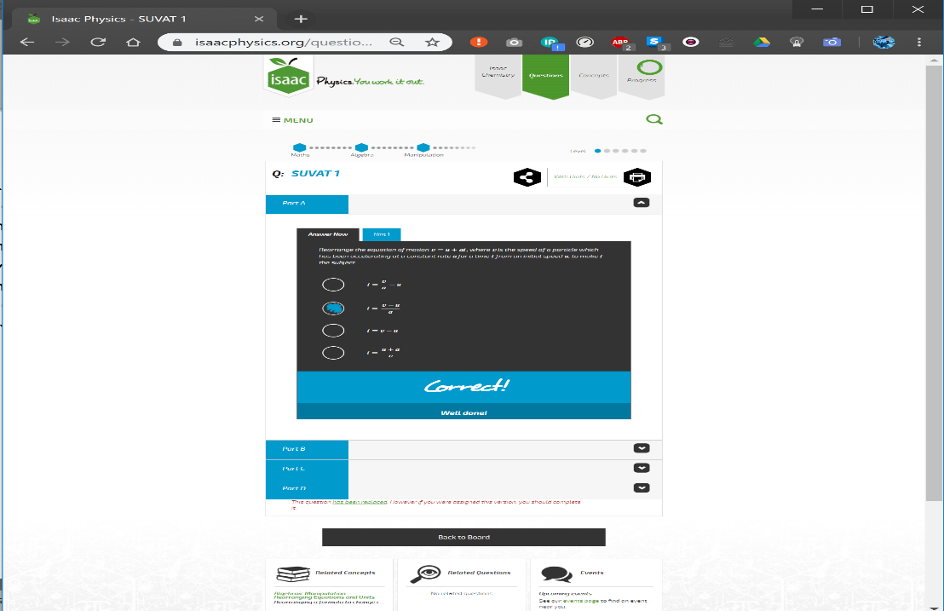

These consist of questions which can be immediately marked to provide quick feedback. The questions have blank boxes, which are filled in right now to indicate their location, with mark allocations beside them. After finishing the questions, the student can press the “Check my answer” button in the bottom left corner originally to receive instantaneous feedback on the completed questions on the page. After marking answers cannot be adjusted without redoing the homework

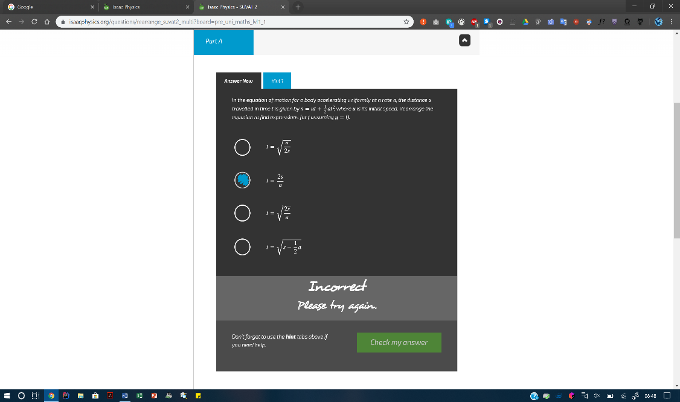If a student makes a mistake whilst doing one of the questions, then they are informed that their solution is incorrect and that they should try again. This could be improved upon by showing where the student lost their marks specifically as on longer questions the mark allocation becomes more complicated to see.

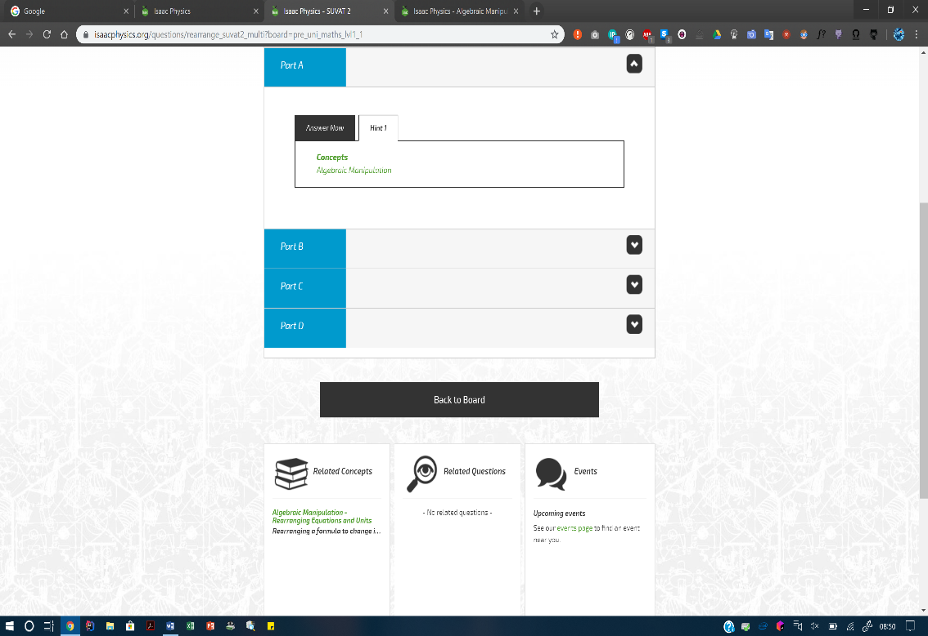Following the prior suggestion to look at the hint, the student is asked to look at the hint which displays a link to the topic of Algebraic Manipulation.

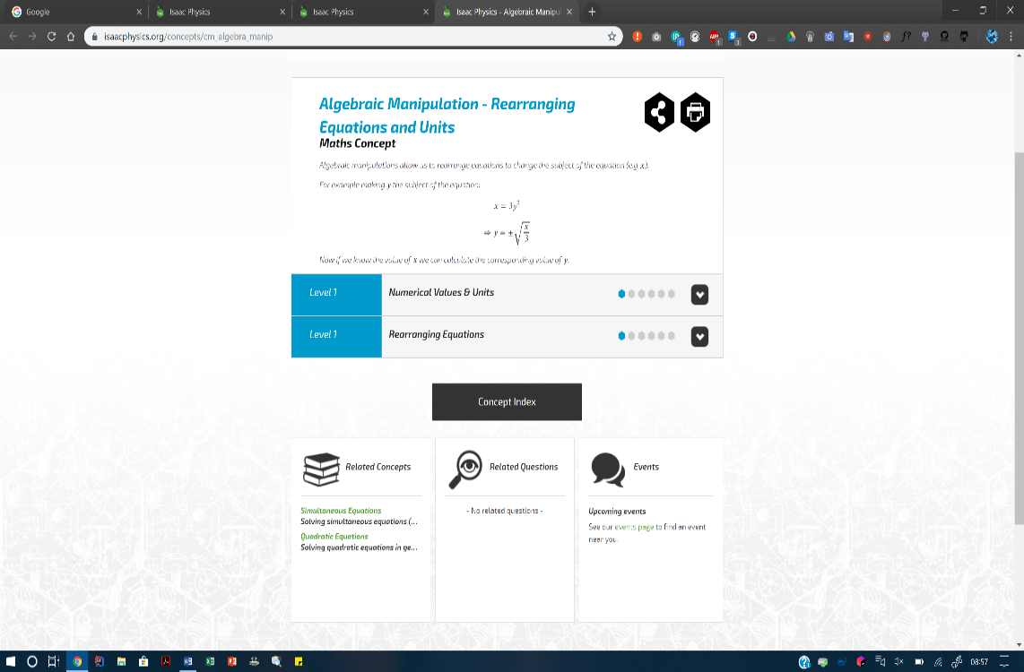Upon clicking on Algebraic Manipulation, the user is greeted with this screen. This allows the user to see different examples if they so wish to help learn how to do the topic.

# Conclusion

Isaac Physics has a high-quality features which would make it a great A Level revision resource if not for its lack of pure mathematics breadth. The instant evaluation allows students to see mistakes quickly. Despite the lacking prior features, the lack of a teacher to sign up may mean that students are more likely to work due to the removal of a “Big Brother”. In Conclusion, Isaac Physics is a helpful aid for student revision but its focus upon physics, which is its primary focus, is not particularly useful for Mathematics students.

# Areas for Development

Following an analysis of the predominant current solutions, I have discovered many potential areas for development for MyMaths and Isaac Physics even though they are relatively popular sites. My project would hopefully incorporate these issues during development so that user has a better experience through a more efficient application.

# MyMaths

A major drawback of using MyMaths is the annual subscription fee of £625 excluding VAT which would likely decrease the likelihood of the resource being available to students in schools with cash-strapped Mathematics Departments due to the opportunity cost of Textbooks and exercise books, which are less-mobile resources. MyMaths requires a substantial amount of teacher input in implementing tasks such as setting work to customizable deadlines for homework and practice; If the teacher chooses not to utilize MyMaths then the student will suffer. MyMaths could also have a tab limiter else multiple tabs opening may cause an overconsumption of memory resulting in negative externalities to other applications or may result in unfortunate accidental tab closures.

When the need for a teacher is removed, the number of students that can use this will increase significantly as for example compared to a Local Authority school someone who is home schooled may be much less likely to pay for a MyMaths subscription. Also, Users can’t be 'guest's if they so wish to not store their details. This means that anyone with an internet capable device and connection cannot use it as they wish.

# Isaac Physics

Isaac Physics across its website has an inconsistency of significant figures which can be frustrating. This is because questions do not request answers to any degree of accuracy e.g. 3 s.f. or 1 d.p. for example yet expects answers in these formats. The provided "Significant Figure Guide" is useless here which is annoying as a question can be mathematically right but wrong due to a lack of significant figures which are not demonstrable by Isaac Physics. Also, Pop ups following a correctly answered question block up the screen which can irritate users.

# CONCLUSION

To conclude, by analysing the competitors in this imperfectly competitive market, I am able to see the pitfalls of these Applications and let my application avoid these issues. Through my survey and analysis, the areas of development which I have isolated are:

* No annoying pop-ups
* Minimal teacher involvement
* Constant degree of accuracy or specified degree of accuracy
* Content specific to new A-Level Mathematics Syllabus
* Consistent user experience

Requirements Sections

# Hardware and software Requirements

|  |  |  |
| --- | --- | --- |
| Type of Requirements | Requirements | Justification |
| Hardware | Internet capable device along with modem/router/telephone line / ADSL | A Modem/Router/Telephone line/ADSL is required to access the internet so that an internet capable device can to access the website. |
| Software | Web browser and ISP | This is needed to browse the pages on the revision site and to access external links. This is also so that internet access is allowed. |

# USER REQUIREMENTS

|  |  |
| --- | --- |
| Type of requirement | Requirement |
| Design | * A clear GUI * Must have A-Level Mathematics questions * Appropriate Display of questions to ensure visibility and continuous design |
| Input | * Input can be taken from the user through a text box to verify numerical evaluations * Users should be able to select questions from a list of topics * Users should be able to select a button to give an answer. |
| Output | * Questions should be displayed appropriately for the user to clearly understand * Users can see how progress they have made across a topic * Users can get instant feedback to answers that are answerable with Boolean condition |
| Processing | * Summarize user progress * Validate the use of user input in cases of degrees of accuracy * Sub topic Map of topic currently being viewed |

Signed by Alan Sounthararajah



DESIGN

Project - Problem Definition

From this, I had the idea to create a system to question users which will eventually be able to be combine analysis of scores to determine links between revision methods and outcomes as well as other factors. The aim is to do this on a small scale by using it primarily within my school. The end goal of this may be to determine the most effective revision and testing methods. For the purposes of this project, the focus will be data collection for analysis. There will not be an ability to submit scores to teachers at this time since this would require a great deal of input from teachers to ensure testing is to their preferences.

The project is going to be a web application that students can submit their answers online on the go. This is going to be powered by a main website (the client) that communicates directly with the backend.

The following points will need to be considered when creating the website:

* Purpose
* Colour scheme
* Information
* Font
* Logo
* Mathematical Notation

Purpose

The websites’ purpose will be shown to the user primarily through the title of the website; This will be appropriately chosen so that any visitor is aware of what the website can be used for. When the user visits a webpage, it should be obvious what it does. This can be done by giving apt headers to each page; Each section should have enough information for the user to understand its’ purpose. When the user goes on the website, they should have the ability to either sign in to track progress or go incognito as a guest to disassociate their progress from their account. On the content page, the most frequent and heavily weighted components of 9MA0 should be displayed. When they click on the pages’ hyperlink, they should be able to get the list of content that is required to be know the new specification, as well as view some notes and auto generated questions,

Colour Scheme

So that the user is not confused, there will a be consistent colour scheme used throughout Arctic Math; This will also help to ensure that the website looks appropriate for a revision resource. If the colour scheme is too dark, users will not be able to answer questions which detracts from the point of using the site in the 1st place. Due to this I believe that the best colour scheme would be Floral White, specifically the HTML code #fffaf0.

Information

The information displayed on each page of Arctic Math needs to be concise so that users are able to navigate the site and see exactly what each webpages’ purpose is but not overwhelm the user with irrelevant details. The information also needs to be clear as users should not be distracted from the websites’ main function. If the user has created an account or used Google Sign-In they should be able to see their account details in the corner of the screen such as their avatar and Username.

Font

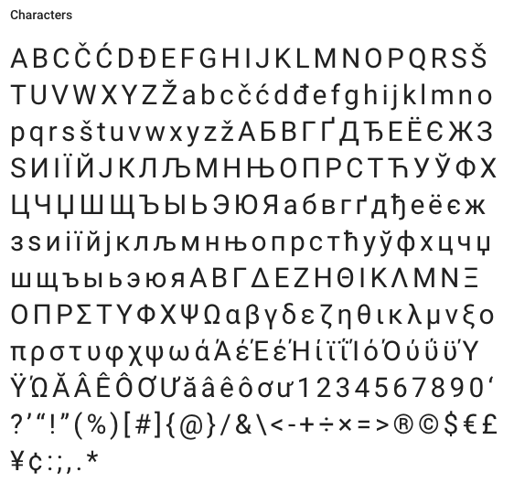So that the user is not confused, there will a be consistent font used throughout Arctic Math. In order to make Arctic Math accessible, the font will be larger so that those who have poor eyesight such as myself can see and so that it is clear to people with dyslexia. However, the font cannot be too bold else reading of letters may be impaired. Some users may choose to visit the website on a mobile phone and so the font cannot be too this as this would once again impair upon the reading of letters.

Due to this I plan on implementing a Google font made by A designer called Christian Robertson. This font is called Roboto. It is a very popular font as Google Fonts API served Roboto “66.7 Billion” times over the last week. Roboto is featured in more than 26,000,000 websites showing its popularity with developers and designers. This neo-grotesque sans-serif font is used by Google as the system font for Android since 2011 and other Google services since 2013 so it is definitely reliable as well as being "modern, yet approachable" and "emotional".

Please see adjacent the Roboto font character set provided by [Google](https://fonts.google.com/specimen/Roboto):

Logo

My Logo for Arctic Math needs to Memorable, Simple and versatile to be effective in its role as a logo. It needs to be memorable in order for the user to remember to use the site if it is in their bookmarks. It needs to be simple and unique so that there is no confusion between other websites or applications and users associate the logo with the website.

Design 1

Design 1 consists of a logo comprised of a red mortarboard on top of 2 books with the words Arctic Math below the logo in Red. It fits the design brief of being simple however the use of colour reduces its versatility due to the requirements of large-scale printing on resources and miscellaneous related merchandise. Moreover, it does not seem to be quite visually appealing and therefore may discourage some of the potential target market audience due to a preconception of the resource being outdated due to the drab logo. To counter this, a newer more modern logo could be used to encourage more students from GCSE, A-Level and University as well as any other international equivalents

Design 2



Design 2 consist of a logo comprised of a pencil sketch of an Arctic Fox as a homage to the website Arctic Math with the words Arctic Math below the logo in Grey. The logo and text could separately if apt or wished.

This logo is more visually appealing and more modern and so should hopefully encourage more users from different education tiers.

CONCLUSION

After conversing with my client, he came to a decision that the 2nd Design was far superior to the 1st as it was more eye-catching and modern meaning that there will be a larger audience for the website. Due to this, I will choose to implement Design 2 throughout the website.

Mathematical Notation

As this project uses A-Level mathematics concepts, there will be a significant amount of mathematical notation to output questions to users. Due to the use of the UTF-8 Unicode Standard, most of the notation can be displayed using just HTML and PHP. There are some problems however such as Square Root not extending for the length of an expression or the division obelus ÷ symbol not being present in the UTF-8 Unicode standard.

This however doesn’t stop from mathematical equations looking out of place or weird which distracts the user from doing the questions. To help stop distractions, I shall integrate MathJax where apt to the topic. This is an open-source JavaScript display engine that works in all modern browsers for Mathematical Notation in LaTeX, MathML, and AsciiMath. There are no setup requirements on the part of the user I.e. no big plugins to download or clunky software to install.

MathJax does this by using web-based fonts in order to produce typesetting of a high-quality that can scale as well as print at full resolution, unlike traditional mathematical notation included as images. For accessibility purposes, MathJax can be used with screen readers, so that those with disadvantaged eyesight and those who are visually impaired can also use the website.

Abstraction diagram (flowchart and pseudocode)

I Have chosen to use a flowchart as my abstraction diagram to show how my algorithm works and how the different webpages connect together. I have chosen to use ‘code2flow’ to make my abstraction diagram as I can type up my diagram in pseudocode so I can visualise the different constructs easily.

code2flow pseudocode

start:

Load Arctic Math Homepage in Browser;//Homescreen

branch(login) [login/signup button clicked]{

if (print "Hi there. Have you used Arctic Math before?")[Yes]{

if (print "Would you like to login?")[Yes]{

if(print "Sure. How would you like to login?")[Regular Sign in clicked]{

int i = 0;

before_regular_login:

i=i+1;

if (i=5)[Login Failure Limit Achieved]{

print "Too many failed attempts. Please retry tomorrow.";

return complete_failure;

}

Enter Username or Email;

Enter Password;

if (click on LOGIN Button)[Successful]{

print"Welcome";

} else[Failure]{

Please try again;

loop before_regular_login

}

}

else[Google Sign In Clicked]{User types in Google Account and Password;// Google handles this

int j=0;

before_google_login:

int j=j+1;

if (j=5)[Login Failure Limit Achieved]{

print "Too many failed attempts. Please retry tomorrow.";

return complete_failure;

}

if (Google gives account)[Successful]{

print"Welcome";

} else[Failure]{

Retry Google Login;

loop before_google_login;

}

}

}

}else[No]{

print"NP";

}

}else{

if (print "Would you like to make an account with Arctic Math or use Google Sign in?")[Yes]{

if(print "Sure. How would you like to make an account?")[Regular Sign in clicked]{

Enter First Name;

Enter Surname;

Enter Phone Number;//Optional

Enter DOB;//Optional

Enter Gender;//Optional

Enter Email;

Enter Username;

Enter Password;

print "Why we process it";

print"We process this data for the purposes described in our policy, including to:";

print"Help our services deliver more useful, customized content such as more questions you are struggling on";

print"Improve the quality of our services and develop new ones";

print"Conduct analytics and measurement to understand how our services are used. ";

if(click "I agree to the Arctic Math Terms of Service"){

if(click "I agree to the processing of my information as described above and further explained in the Privacy Policy"){

if (click on LOGIN Button)[Username available]{

print"Welcome";

} else[Failure]{

}}

else{print"Sorry to see to feel that way";

}

}

else

print"Sorry to see to feel that way";

}

}

else[No]{

print"NP";

}

}

Development

To create this website I have used HTML, CSS and PHP.

User Interface

Home Page

<!DOCTYPE html>

<html lang="en-UK">

<meta charset="UTF-8">

<meta content="width=device-width, initial-scale=1" name="viewport">

<link href="style.css" rel="stylesheet" type="text/css">

<head>

<title>Arctic Math</title>

</head>

<div id="g-signin">

<script src="https://apis.google.com/js/platform.js" async defer></script>

<meta name="google-signin-scope" content="profile email">

<meta name="google-signin-client_id" content="215405045709-h89405dp4slh64sfdli5903i881a1flq.apps.googleusercontent.com">

<script src="https://apis.google.com/js/platform.js" async defer></script>

<div class="g-signin2" data-onsuccess="onSignIn" data-theme="dark"></div>

</div>

<body>

<h1>Hello Mathematicians :)</h1>

<hr>

<br>

<p>Welcome to a great study resource for any A Level Mathematician

<br><strong>as well as</strong><br> for anyone looking for extension/revision work.

</p>

<br>

<p> Why don't you see a random topic. How about <a href="QuadraticEquationsDisplay.php">this.</a></p>

</body>

<h2>Copyright &copy; 2018 Mark R. Sounthararajah</h2>

</html>

CSS for Home Page

title {

font-family: 'Roboto', sans-serif;

/*background-color: #000000;*/

}

body {

background-color: floralwhite;

/*background-image: url("MathFrontCover.jpg");*/

}

#g-signin {

margin-left:40px;

margin-top: auto;

margin-right: auto;

}

h1 {

color: lightblue;

text-align: center;

margin-left: auto;

margin-right: auto;

}

h2 {

text-align: center;

}

p {

color: darkblue;

text-align: center;

font-family: 'Roboto', sans-serif;

}

Quadratic Equations Displaying

<!DOCTYPE html>

<html>

<html lang="en-UK">

<meta charset="UTF-8">

<meta content="width=device-width, initial-scale=1" name="viewport">

<link href="QuadraticEquationsDisplay.css" rel="stylesheet" type="text/css">

<head>

<title>Arctic Math</title>

</head>

<h1>Quadratic Equation</h1>

<body>

<p>To solve a <a href="https://en.wikipedia.org/wiki/Quadratic_equation">Quadratic equations.</a> of the form ax<sup>2</sup> + bx + c = 0 there are some steps you need to take rather than just putting it in a calculator.

<br> In an Examination you need to show your working for crucial method marks .

<br>You can <a href="http://www.mathcentre.ac.uk/resources/workbooks/mathcentre/web-factorisingquadratics.pdf">factorise</a> the equation or try to <a href="http://www.mathcentre.ac.uk/resources/uploaded/mc-ty-completingsquare2-2009-1.pdf">complete the square</a>.

<br> if you can't or unable to do the two preceding methods then For those types of equations you should use the formula: </p>

<div id="Div1"name="QuadEqnFor" title="Quadratic Formula";>

<input type="image" src="https://wikimedia.org/api/rest_v1/media/math/render/svg/2a9804ca8ce019507e3199ca8fced800fb5b7d7c" />

</div>

<hr>

<?php

include ('QuadraticEquations.php');

?>

<h2>Copyright &copy; 2018 Mark R. Sounthararajah</h2>

</body>

</html>

The CSS for displaying the Quadratic Equation Topic

title {

font-family: 'Roboto', sans-serif;

/*background-color: #000000;*/

}

body {

background-color: floralwhite;

/*background-image: url("MathFrontCover.jpg");*/

}

h1 {

color: lightblue;

text-align: center;

margin-left: auto;

margin-right: auto;

}

h2 {

text-align: center;

}

p {

color: darkblue;

text-align: center;

font-family: 'Roboto', sans-serif;

}

Question Algorithms

The question algorithms have been placed in separate PHP Files so that there is little interdependence bar a PHP file which contains some reused algorithms that are useful in a large breadth of scenarios.

Quadratic Equation

The aim of this function is to generate solvable Quadratic Equations.

<?php

$a = (double)0;

$b = (double)0;

$c = (double)0;

$d = (double)0;

do{

do {

try {

$a = random_int(-5, 5);

} catch (Exception $e) {

}

try {

$b = random_int(-10, 10);

} catch (Exception $e) {

}

try {

$c = random_int(-5, 5);

} catch (Exception $e) {

}

try {

$d = random_int(-10, 10);

} catch (Exception $e) {

}

} while ($a === 0 || $b === 0 || $c === 0 || $d === 0);//Start with (ax-b)(cx-d)=0

$g = $a * $c;

$h = -(($a * $d) + ($b * $c));

$k = $b * $d;

//Coefficients of the equation generated by the expansion of (ax-b)(cx-d)

$d1 = ($h ** 2) - (4 * $g * $k);

//The discriminant of the newly generated equation

$turning_point_prefix='The turning point of the quadratic equation is ';

$turning_point_suffix=' This is a ';

$x_turning_point=(-$h)/(2*$g);

$y_turning_point = $k - (($h ** 2) / (4 * $g));

$type_of_turning_point='turning point of the quadratic equation.';

$concavity = 2 * $g;//The coefficient of x in the gradient or the 2nd Derivative

if ($concavity > 0) {

$type_of_turning_point='local minimum';

} else if ($concavity < 0) {

$type_of_turning_point='local maximum';

}

$turning_point=$turning_point_prefix.$x_turning_point.$y_turning_point.$turning_point_suffix.$type_of_turning_point;

$root1 = $b / $a;

$root2 = $d / $c;

if($root1!==$root2) {

$roots = array('Root 1' => $root1, 'Root 2' => $root2);

$root_type = 'This quadratic equation has 2 distinct real roots.';

$equation_suffix = 'Find the possible values of x when y crosses the x-axis.';

}

else {

$roots=array('Root 1' => $root1);//This is the repeated root

$root_type = 'This quadratic equation has a single repeated real root.';

$equation_suffix = 'Find the value of x when y crosses the x-axis.';

}// Root Type could be implemented as a hint

} while ($g === 0 || $h === 0 || $k === 0 ||$d1 < 0);

echo $g.",".$h.",".$k.".";

$bar = '----------------------------------------------------------------------------------';

if ($g===1){ $g1=null;}

elseif ($g=== -1){$g1=null; $g1=sprintf('%-d',$g);}

else {$g1=$g;}

if ($h===1){$h1=null;$h1=sprintf('%+d',$h1);}

elseif ($h=== -1){$h1=null; $h1=sprintf('%-d',$h)}

elseif ($h< 0){$h1 = $h;}

else {$h1=sprintf('%+d',$h1);}

if ($k>0){$k1 = sprintf('%+d',$k);}

else {$k1 = $k;}

if ($concavity===1){ $concavity1=null;}

elseif ($concavity=== -1){$concavity1=null; $concavity1=sprintf('%-d',$concavity1);}

else {$concavity1=$concavity;}

if ($h> 0){$h = sprintf('%+d',$h);}

$equation = ' y = ' . $g1 . 'x^2 ' . $h1 . 'x ' . $k1 . "\n";

$gradient = $concavity . 'x ' . $h;

//echo 'y = ' . $g . 'x^2 ' . $h . 'x ' . $k . "\n";

echo " ".$equation . "\n" . $bar . "\n";

/* This generates a valid quadratic equation as well as a hint and its roots*/

?>

Firstly, the variables a,b,c and d are initialized as doubles. PHP is a loosely typed language so initialising of variables is not typically required but PHPs’ typecasting did cause some problems later on so this was prevented. Following this a do while loop generates random values for a and c between –5 and 5 and b and d between –10 and 10. This is give suitable numbers to simulate an expansion of the equation (ax-b)(cx-d)=0 . This is contained within another do while loop where the variables g , h and k are made.

The variable g is set to the value of the variable a multiplied by the variable c whilst the variable h is set to the value of minus 1 multiplied by the sum of the multiplication of a and d and the multiplication of b and c . The variable k is set to the value of the b multiplied by d. This generates a new equation of the form gx2+hx+k=0

After these variables have been created, the variable d1 is set to the value of h squared take away 4 multiplied by g and multiplied by k. This is where d1 is the new discriminant of gx2+hx+k=0.

For later use details about the turning point are stored in an array. The concavity is stored where it is the 2nd Derivative of gx2+hx+k .The roots are placed into an array which helps form the end part of the question as it is dependent on how many roots there are.

There are a couple of if elseif else blocks to ensure that accurate equations are outputted which is another problem I came across.

PROBLEMS DURING DEVELOPMENT

Outputting Errors

As positive are stored without signage, when outputting the h and k values there would be problems with an incorrect display. To fix this the sprintf string handling function was used. However, this unearthed another problem. If g or h were plus or minus 1 they should not be fully outputted as non-prefixed algebraic terms are widely assumed to be of the value 1. To conunter this I created new variables called g1 , h1 and k1 respectively to dislay the final coefficients.

Mathematical errors

My First approach to generating quadratic equations was not very successful. What I Initially attempted to do was generate a , b and c of the equation.

try { $a = random_int(-10, 10); } catch (Exception $e) { }//Coefficient of x^2

try { $b = random_int(-50, 50); } catch (Exception $e) { }//coefficient of x

try { $c = random_int(-25, 25); } catch (Exception $e) { }//y intercept

These values were later used to calculate the discriminant.

$d = $b**2-4*$a*$c;

This value would sometimes become negative which was unavoidable in the current format of generating the coefficients. To calculate the roots (answers) one must square root the discriminant as it is said in the quadratic formula. As any mathematician would tell you square rooting a negative value gives you an imaginary value where i is equal to the square root of –1. However, attempting to generate complex numbers in the PHP Engine proved to be too complex unfortunately.

In addition, when I was starting off making the Quadratic Equation Generator, a common problem occurring was random crashes when adding values to an array. At the time, I was only adding the answers (roots) to an array to call later so I knew it had to be because of this. The values going into the array were derived by doing calculations from numbers created by the random number generator as It was generating 4 numbers a, b, c and d in order to later simulate the mathematical expansion of (ax+b) (cx+d) . A and c were in the range of plus or minus 5 whilst b and d were generated in the range of plus or minus 10. Due to this a or c could have the value 0 generated as its value. This would mean later when the roots were calculated as -b/a and -d/c the program would attempt to divide by 0 which is not possible and so there would be an error. To remedy this problem, I placed the block of code generating the numbers in a do while loop ensuring that none of the values could be 0

Logical errors

Whilst I was creating the do while loops for the Quadratic Equation Generator, I believed that I should use the && (and) operator in my loops. I unfortunately was not aware at the time of the havocs this would wreak on my codes’ intended purpose. Following from earlier, I Had prevented division by 0 but the && operator meant that the loop would not repeat unless all the conditions were satisfied which is not what I wanted to occur. In my while loop I had 4 conditions of a, b, c and d === 0. A new set of numbers would not be generated even if 3, 2 or 1 of the values were 0 which would cause problems down the line when placing the roots (answers) into an array.

To remedy this problem, it was suggested to me by a peer that I try and swap my logical operators to some other logical operator. Following this I found the || (or) operator which would ensure that the loop would be executed repeatedly until all of the conditions were false. Due this there was no longer an error with sending the values of the roots to an array.

Testing

White box testing

This type of testing aims to test the internal structure of the application rather than the functionality which is done in black-box testing. To do white box testing I shall be testing the conditional loops in my code so that the expected output of the program is produced. This allows me to be introspective about my development process

|  |  |  |  |  |  |
| --- | --- | --- | --- | --- | --- |
| Test No | Test Description | Input | Data Type | Expected Result | Comment |
| 1 | Test Quadratic Equation Generator | QuadraticEquationDisplay | Normal | A solvable Quadratic Equation of the form ax2+bx+c=0 |  |

Black Box Testing

This type of testing aims to test the application functionality To do black box testing I shall be testing the application against the requirements.

|  |  |  |  |  |  |
| --- | --- | --- | --- | --- | --- |
| Test No | Test Description | Input | Data Type | Expected Result | Comment |
| 1 | Test Quadratic Equation Generator | QuadraticEquationDisplay | Normal | A solvable Quadratic Equation of the form ax2+bx+c=0 |  |

Alpha Testing

This type of testing is acceptance testing . This will simulate a user.

|  |  |  |  |  |
| --- | --- | --- | --- | --- |
| Test Subject | Test example | Relation to success Criteria | Explanation | Success Criteria Number |
| Hyperlinks | Clicking on a Hyperlink | All Links should work and take users to the right page | This checks that each page is consistent and flows. This also checks that that all the Hyperlinks work and take users to the intended destination | 1,3,5 |
| Viewing Question | Valid Question Generated | Give the users the ability to view random questions | This is checking that the user can actually solve the question. | 1,2,7 |

Beta Testing

This type of testing will be done by other prospective users.

|  |  |  |  |  |
| --- | --- | --- | --- | --- |
| Test Subject | Test example | Relation to success Criteria | Explanation | Success Criteria Number |
| Hyperlinks | Click on random topic link | Clickable link that will take user to a different page | Makes sure that users can go to a random topic | 1,3,5 |
| Viewing Question | Valid Question Generated | Every question outputted should be solvable | Makes sure that users aren’t wasting their time trying to solve questions that are unsolvable withoit knowledge of A Level Further Mathematics i.e. Needing to use complex numbers wher | 1,2,7 |

User Acceptance Testing

|  |  |  |
| --- | --- | --- |
| Test No. | Test Description | User Evaluation |
| 1 | Easy to understand design | Client thought the minimalistic look of the website was helpful for revision as it reduced distraction |
| 2 | Random link | The client is a repeat user of the <https://theuselessweb.com> and so enjoyed the fact that the random link on the homepage took him to another topic |
| 3 | Solvable Questions validity | The Client was able to solve the questions with the right answer which can sometimes be problematic on MyMaths in particular which I mentioned earlier in my Analysis of competitors. He did point out however that he would of prefer proper scripting I.e. superscripting for powers of x and subscripting when viewing Integrals of a certain parameter perhaps in future development iteration cycles . |
|  |  |  |

Evaluation

Evaluation of Requirement Specification

|  |  |  |  |
| --- | --- | --- | --- |
| Requirement Type | Requirements | Justification | Evaluation |
| Hardware | internet capable device along with modem/router/telephone line / ADSL | A Modem/Router/Telephone line/ADSL is required to access the internet so that an internet capable device can to access the website. | The requirements were met |
| Software | Web browser and ISP | This is needed to browse the pages on the revision site and to access external links. This is also so that internet access is allowed. | The requirements were met. The website works in Chrome and Safari which are by far the most popular browsers. |

User Requirements

|  |  |  |
| --- | --- | --- |
| Type of requirement | Requirement | Evaluation |
| Design | * A clear GUI * Must have A-Level Mathematics questions * Appropriate Display of questions to ensure visibility and continuous design | 1. This requirement was met as there is not a CLI 2. This requirement was also met as the questions were available 3. This requirement was met as the questions are displayed clearly |
| Input | * Input can be taken from the user through a text box to verify numerical evaluations * Users should be able to select questions from a list of topics * Users should be able to select a button to give an answer. | 1. This requirement was disregarded during development, as users could mark their own answers if shown the appropriate steps needed to gain the marks in the exam as if they cheat, they do not affect others and are only hurting their own prospects. 2. This requirement was partially met as there is only one topic currently functioning 3. This requirement was disregarded during development, as users could mark their own answers and in the 9MA0 exam there are no Multiple-Choice Questions. |
| Output | * Questions should be displayed appropriately for the user to clearly understand * Users can see how progress they have made across a topic * Users can get instant feedback to answer that are answerable with Boolean condition | 1. This requirement was met as the questions are displayed clearly and are presentable 2. This requirement was not met due to the time constraints and wasting of time at the start of the project being pedantic 3. This requirement was disregarded during development, as users could mark their own answers |
| Processing | * Summarize user progress * Validate the use of user input in cases of degrees of accuracy * Sub topic Map of topic currently being viewed | 1. This requirement was not met due to the lack of knowledge of the most effective display of progress as a negative display could disincentivize a student making them feel useless and may stop revision which is definitely not what is needed for the student. 2. This requirement was partially met as there is only one topic currently functioning and this does not require degrees of accuracy 3. This requirement was not met due to the time constraints and wasting of time at the start of the project. |

Possible Improvements

Reminders to Revise

A Reminder would let the user know that they should be revising if they haven’t visited the website by the most common time that they start revising on the website.

To send a traditional reminder a text or email would be sent but storing these would have to comply with EU GDPR Regulations. Alternatively, there could be push notifications to phones however this would require additional permissions and A always on server connected to the internet mainly. This would take a large amount of additional work to ensure compliance and a database would be needed to store last logins and such.

Generating a Report of Problem Areas and Strong Areas

This would include sending users an email about all the questions that they have done and this could highlight their main strengths and weaknesses. The scores would already be stored in a database which users could see but the report could have a better statistical analysis of the users' progress. This information should be easy to digest and have an option to filter out outliers as detected by the program or the user after confirmation.

Limitations

Maintenance

So that someone else or myself in the future can improve this program I have implemented certain characteristics into it. Firstly, I have annotated the important parts of my code heavily so that developers in the future can clearly see the purpose of what each block does. I have not used simple variable names like ‘a’, ‘b’ or ‘c’ commonly and where I have, I have clearly shown what they mean in comments. This will ensure that the purpose of each variable can be seen clearly by anyone reading the code on GitHub. If someone makes an edit than they should comment what they have edited , their name and the date so if there are problems down the line then it can traced back to an origin point. I have indented my code so that it is easy to read and update swell as debug.

Final Evaluation

In Conclusion, unfortunately some of the user requirements were not met and therefore the website was not a success. The client agrees with this but is pleased that he can at least do some revision on the website. The remaining user requirements would need to be accomplished through going back to the drawing board and implementing a more effective way of accomplishing the requirements.